RTX9430 VoIP System Guide

  - Installation & Configuration
  - Network Deployment
  - Operation & Management

Technical Reference Document
Version 2.4
© April-2014 RTX A/S, Denmark

Trademarks

RTX and the combinations of its logo thereof are trademarks of RTX A/S, Denmark.
Other product names used in this publication are for identification purposes and maybe the trademarks of their respective companies.

Disclaimer

The contents of this document are provided in connection with RTX products. RTX makes no representations with respect to completeness or accuracy of the contents of this publication and reserves the right to make changes to product descriptions, usage, etc., at any time without notice. No license, whether express, implied, to any intellectual property rights are granted by this publication

Confidentiality

This document should be regarded as confidential, unauthorized copying is not allowed

© September-2014 RTX A/S, Denmark, All rights reserved
http://www.rtx.dk

Contents
RTX9430 VoIP System Guide 1
1
Contents 3
1 About This Document 6
1.1 Audience 6
1.2 When Should I Read This Guide 6
1.3 Important Assumptions 6
1.4 What’s Inside This Guide 6
1.5 What’s Not in This guide 7
1.6 Abbreviations 7
1.7 References/Related Documentation 8
1.8 Document History 8
1.9 Documentation Feedback 8
2 Introduction – System Overview 9
2.1 Hardware Setup 9
2.2 Components of RTX9430 VoIP System 9
2.3 Wireless Bands 10
2.4 System Capacity (in Summary) 10
3 Installation of Base Station/Repeater 11
3.1 Package – Contents/Damage Inspection 11
3.2 RTX Base station Mechanics 12
3.3 RTX Base Unit – Reset feature 12
3.4 Installing the Base Station 13
3.5 Find IP of Base Station 13
3.6 Login to Base Configuration Interface 14
4 Making Handset Ready 15
4.1 Package – Contents/Damage Inspection 15
4.2 Before Using the Phone 16
4.3 Using the Handset 17
5 VoIP Administration Interface 18
5.1 Web navigation 18
5.2 Home/Status 20
5.3 Extensions 21
5.4 Servers 26
5.5 Network 30
5.6 Management Settings Definitions 34
5.7 Firmware Update Definitions 37
5.8 Time Server 38
5.9 Country 40
5.10 Security 41
5.11 Central Directory and LDAP 43
5.12 Repeaters 46
5.13 Alarm 50
5.14 Statistics 52
5.15 Settings – Configuration File Setup 56
5.16 Sys log 56
5.17 SIP Logs 57
6 Registration Management - Handset 58
6.1 Register handset to base 58
7 Firmware Upgrade Procedure 61
7.1 Network Dimensioning 61
7.2 TFTP Configuration 61
7.3 Create Firmware Directories 62
7.4 Firmware Update Settings 64
7.5 Base Station Firmware Upgrade 64
7.6 Handset(s) and Repeater Firmware Upgrade 66
8 Functionality Overview 68
8.1 Base Station Interfaces 68
8.2 Software Features 69
8.3 Call Features 70
Appendix 72
9 Appendix A: Basic Network Server(s) Configuration 72
9.1 Server setup 72
9.2 Requirements 72
9.3 DNS Server Installation/Setup 72
9.4 DHCP Server Setup 72
9.5 TFTP Server Setup 74
9.6 SIP Server Setup 75
10 Appendix B: Using Base with VLAN Network 78
10.1 Introduction 78
10.2 Backbone/ VLAN Aware Switches 79
10.3 How VLAN Switch Work: VLAN Tagging 80
10.4 Implementation Cases 80
10.5 Base station Setup 81
10.6 Configure Time Server 81
10.7 VLAN Setup: Base station 82
11 Appendix C: Local Central directory file handling 83
11.1 Central Directory Contact List Structure 83
11.2 Central Directory Contact List Filename Format 83
11.3 Import Contact List to Central Directory 84
11.4 Central directory using server 85
11.5 Verification of Contact List Import to Central Directory 85

About This Document
This document describes the configuration, customization, management, operation, maintenance and trouble shooting of the VoIP System (RTX9430 base, RTX8630 handset, RTX8430 handset and RTX4024 Repeater) in RTX generic mode. For customer specific modes refer to specific customer agreements, which describe the software operational deviations from this document. For handset detailed user guide refer to [1].

Audience

Who should read this guide? First, this guide is intended for networking professionals responsible for designing and implementing RTX based enterprise networks.
Second, network administrators and IT support personnel that need to install, configure, maintain and monitor elements in a “live” VoIP network will find this document helpful. Furthermore, anyone who wishes to gain knowledge on fundamental features in the Beatus system can also benefit from this material.

When Should I Read This Guide

Read this guide before you install the core network devices of VoIP System and when you are ready to setup or configure SIP server, NAT aware router, advanced VLAN settings, base stations, and multi cell setup.

This manual will enable you to set up components in your network to communicate with each other and also deploy a fully functionally VoIP System.

Important Assumptions

This document was written with the following assumptions in mind:
- You have understanding of network deployment in general
- You have working knowledge of basic TCP/IP/SIP protocols, Network Address Translation, etc...
- A proper site survey has been performed, and the administrator have access to these plans

What’s Inside This Guide

We summarize the contents of this document in the table below:

Where Is It? | Content | Purpose
Chapter 2 | Introduction to the VoIP Network | To gain knowledge about the different elements in a typical VoIP Network
Chapter 3 | Installation of Base station/Repeater | Considerations to remember before unwrapping and installing base units and repeaters
Chapter 4 | Making Handsets Ready | To determine precautions to take in preparing handsets for use in the system
Chapter 5 | VoIP Administration Interface | To learn about the Configuration Interface and define full meaning of various parameters needed to be setup in the system.
Chapter 6 | Registration Management - Handsets | Learn how to register handset and extensions to base stations
Chapter 7 | Firmware Upgrade/Downgrade Management | Provides the procedure of how to upgrade firmware to base stations and/or handsets and/or repeaters
Chapter 8 | System Functionality Overview | To gain detail knowledge about the system features.
9 Appendix A | Basic Network Servers Configuration | To learn about operating the handset and base stations including detail description of handset MMI.
10 Appendix B | VLAN Setup Management | Examines how to setup VLAN in the network
11 Appendix C | Local central directory file handling | Detailed description of central directory file format and upload.

What’s Not in This guide

This guide provides overview material on network deployment, how-to procedures, and configuration examples that will enable you to begin configuring your VoIP System.

It is not intended as a comprehensive reference to all detail and specific steps on how to configure other vendor specific components/devices needed to make the VoIP System functional. For such a reference to vendor specific devices, please contact the respective vendor documentation.

Abbreviations

For the purpose of this document, the following abbreviations hold:

DHCP: Dynamic Host Configuration Protocol
DNS: Domain Name Server
HTTP(S): Hyper Text Transfer Protocol (Secure)
(T)FTP: (Trivial) File Transfer Protocol
IOS: Internetworking Operating System
PCMA: A-law Pulse Code Modulation
PCMU: mu-law Pulse Code Modulation
PoE: Power over Ethernet
RTP: Real-time Transport Protocol
RPORT: Response Port (Refer to RFC3581 for details)
SIP: Session Initiation Protocol
VLAN: Virtual Local Access Network
TOS: Type of Service (policy based routing)
URL: Uniform Resource Locator
UA: User Agent

References/Related Documentation
[1]: RTX8430 Handset_Manual_Operations_v1.1
RTX8630 Handset_Manual_Operations_v1.2
RTX8830_Handset_Manual_Operations V1.3
[2]: How to Deploy SME VOIP System v1.1
[3]: Provisioning of SME 2.VoIP System (8)

Document History

Revision | Author | Issue Date | Comments
2.3 | KMR | 24-Sep-2014 | First version
2.4 | KMR | 5-Jan-2015 | Aligned with V323B14 operation

Documentation Feedback

We always strive to produce the best and we also value your comments and suggestions about our documentation. If you have any comments about this guide, please enter them through the Feedback link on the RTX website. We will use your feedback to improve the documentation.

Introduction – System Overview

In a typical telephony system, the network setup is the interconnection between Phones, “fat” routers, repeaters, portable parts, etc. The back-bone of the network depends on the deployment scenario but a ring or hub topology is used. The network has centralized monitoring, and maintenance system.

The RTX9430 is a single cell VoIP solution with support of up to 20 registered handsets (RTX8630, RTX8830 and RTX8430). The base supports the IP DECT CAT-IQ repeater RTX4024 with support up to 5 channels simultaneous call sessions.

Hardware Setup

RTX9430 network hardware setup can deployed as follows:
The base-stations are mounted on walls or lamp poles so that each base-station is separated from each other by up to 10m indoor. Radio coverage can extended using repeaters. Repeaters are range extenders and cannot be used to increase local capacity issues.

The base-station antenna mechanism is based on space diversity feature which improves coverage. The base-stations uses complete DECT MAC protocol layer and IP media stream audio encoding feature to provide up to 6 simultaneous calls.

Components of RTX9430 VoIP System

RTX9430 VoIP system is made up of (but not limited to) the following components:
- One RTX9430 Base Station is connected over an IP network and using DECT as air-core interface.
- RTX IP DECT wireless Handset.
- RTX VoIP Configuration Interface; is a management interface for RTX9430 Wireless Solution.

RTX9430 Base Station
The Base Station converts IP protocol to DECT protocol and transmits the traffic to and from the end-nodes (i.e. wireless handsets) over a channel. It has 6 available channels.

VoIP Administration Server/Software
This server is referred to as VoIP Configuration Interface.
The VoIP Configuration Interface is a web based administration page used for configuration and programming of the base station and relevant network end-nodes. E.g. handsets can be registered or de-registered from the system using this interface.
The configuration interface can be used as a setup tool for software or firmware download to base stations, repeaters and handsets. Further, it is used to check relevant system logs that can be useful to administrator. These logs can be used to troubleshoot the system when the system faces unforeseen operational issues.

RTX Wireless Handset
The handset is a lightweight, ergonomically and portable unit compatible with Wideband Audio (G.722), DECT, GAP standard, CAT-iq audio compliant.
The handset includes Colour display with graphical user interface. It can also provide the subscriber with most of the features available for a wired phone, in addition to its roaming and handover capabilities. Refer to the relevant handset manuals for full details handset features.

Wireless Bands

The bands supported in the VoIP are summarized as follows:
Frequency bands: 1880 – 1930 MHz (DECT)
1880 – 1900 MHz (10 carriers) Europe/ETSI
1910 – 1930 MHz (10 carriers) LATAM
1920 – 1930 MHz (5 carriers) US

System Capacity (in Summary)

network capacity of relevant components can be summarised as follows:
Description | Capacity
Single Cell Setup | 1
Max ## of Repeaters | 3 per Base station
Max ## of Users (SIP registrations) per Base | 20
Single Cell Setup: Max ## Simultaneous Calls | 6
Repeater: Max ## of Calls (Narrow band) | 5
Repeater: Max ## of Calls (G722) | 2

Installation of Base Station/Repeater

In the following we briefly describe the how to install the base station in this chapter.

Package – Contents/Damage Inspection

Before Package Is Opened:
Examine the shipping package for evidence of physical damage or mishandling prior to opening. If there is a proof of mishandling prior to opening, you must report it to the relevant support centre of the regional representative or operator.

Contents of Package:
Make sure all relevant components are available in the package before proceeding to the next step.
Every shipped base unit package/box contains the following items:
- 2 x mounting screws and 2 x Anchors
- 1 x Cat. 5 cable (Ethernet cable)
- Base unit
- Power supply
Damage Inspection:
The following are the recommended procedure for you to use for inspection:
- Examine all relevant components for damage.
- Make a “defective on arrival – DOA” report or RMA to the operator. Do not move the shipping carton until it has been examined by the operator. If possible send pictures of the damage. The operator/regional representative will initiate the necessary procedure to process this RMA. They will guide the network administrator on how to return the damaged package if necessary.
- If no damage is found then unwrap all the components and dispose of empty package/carton(s) in accordance with country specific environmental regulations.

RTX Base station Mechanics

The base station front end shows an LED indicator that signals different functional states of the base unit and occasionally of the overall network. The indicator is off when the base unit is not powered.
The table below summarises the various LED states:

LED State | State
Unlit | No power in unit
Unlit/Solid red | Error condition
Blinking green | Initialisation
Solid red | Factory reset warning or long press in BS reset button
Blinking red | Factory setting in progress
Solid green | Ethernet connection available (Normal operation)
Blinking red | Ethernet connect not available OR handset de/registration failed
Solid red | Critical error (can only be identified by RTX Engineers). Symptoms include no system/SIP debug logs are logged, etc.
Orange | Press reset button of base station.
Blinking orange | No IP address received

RTX Base Unit – Reset feature

It is possible to restart or reset the base station unit by pressing a knob at the rear side of the unit. Alternatively, it can be reset from the VOIP Configuration Interface.

Installing the Base Station

First determine the best location that will provide an optimal coverage taking account the construction of the building, architecture and choice of building materials.
Next, mount the Base Station on a wall to cover range between 50 – 300 meters (i.e. 164 to 984 feet), depending whether it’s an indoor or outdoor installation.

Mounting the Base Stations/Repeaters:
We recommend the base station be mounted an angle other than vertical on both concrete/wood/plaster pillars and walls for optimal radio coverage. Avoid mounting the base units upside down as it significantly reduces radio coverage.

Mount the base unit as high as possible to clear all nearby objects (e.g. office cubicles and cabinets, etc.). Occasionally extend coverage to remote offices/halls with lower telephony users by installing Repeaters.
Make sure that when you fix the base stations with screws, the screws do not touch the PCB on the unit. Secondly, avoid all contacts with any high voltage lines.

Find IP of Base Station
To find IP of the installed base station two methods can be used; Using handset Find IP feature or browser IPDECT feature.

Using handset Find IP feature
On the handset press “Menu” key followed by the keys: *47* to get the handset into find bases menu. The handset will now scan for bases. Depending on the amount of powered on bases with active radios and the distance to the base it can take up to minutes to find a base.

- Use the cursor down/up to select the base MAC address for the base
- The base IP address will be shown in the display

The feature is also used for deployment. For further details refer to reference [2].

Using browser IPDECT
Open any standard browser and enter the address:
http://ipdect<MAC-Address-Base-Station>
for e.g. http://ipdect00087B00AA10. This will retrieve the HTTP Web Server page from the base station with hardware address 00087B00AA10.
This feature requires an available DNS server.

Login to Base Configuration Interface

- Connect the Base station to a private network via standard Ethernet cable (CAT-5).

- Use the IP find menu in the handset (Menu * 4 7 *) to determine the IP-address of the base station by matching the MAC address on the back of the base station with the MAC address list in the handset.

- On the Login page, enter your authenticating credentials (i.e. username and password). By default the username and password is admin. Click OK button.

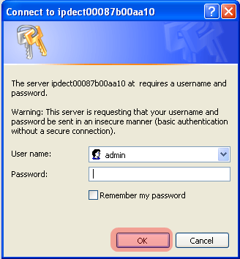

- Once you have authenticated, the browser will display front end of the Configuration Interface. The front end will show relevant information of the base station.

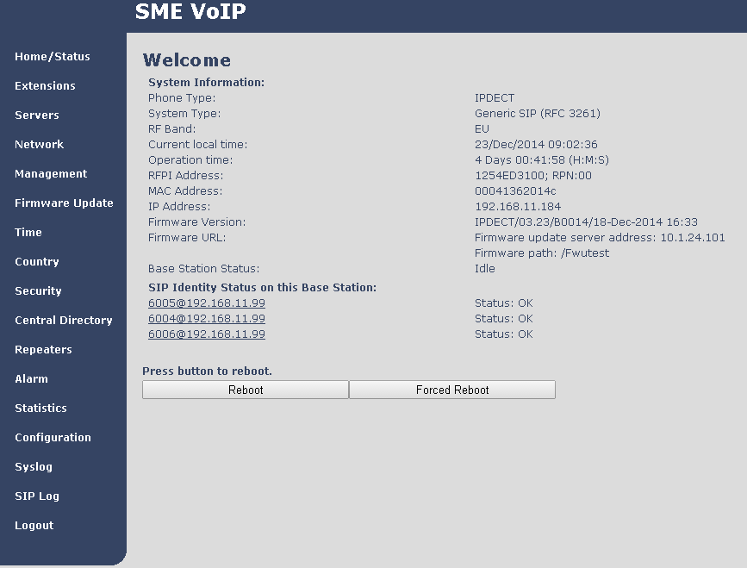

Making Handset Ready

In this chapter we briefly describe how to prepare the handset for use, install, insert and charge new batteries. Please refer to an accompanying Handset User Guide for more information of the features available in the Handset.

Package – Contents/Damage Inspection

Before Package Is Opened:
Examine the shipping package for evidence of physical damage or mishandling prior to opening. If there is a proof of mishandling prior to opening, you must report it to the relevant support centre of the regional representative or operator.

Contents of Package:
Make sure all relevant components are available in the package before proceeding to the next step.
Every shipped base unit package/box contains the following items:
- 2 x mounting screws and 2 x Anchors
- 1 x Handset hook
- 1 x A/C Adaptor
- 1 x Battery
- 1 x charger
- 1 x Handset Unit, 1 x Battery cover
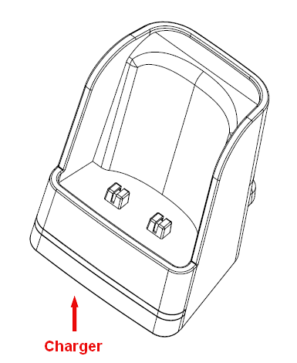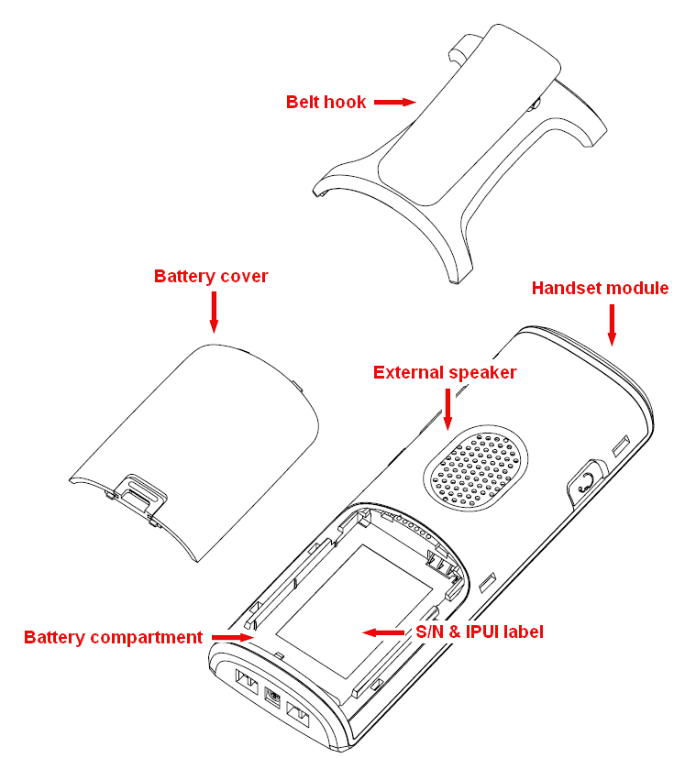

Damage Inspection:
The following are the recommended procedure for you to use for inspection:
- Examine all relevant components for damage.
- Make a “defective on arrival – DOA” report or RMA to the operator. Do not move the shipping carton until it has been examined by the operator. The operator/regional representative will initiate the necessary procedure to process this RMA. They will guide the network administrator on how to return the damaged package if necessary.
- If no damage is found then unwrap all the components and dispose of empty package/carton(s) in accordance with country specific environmental regulations.

Before Using the Phone

Here are the pre-cautions users should read before using the Handset:

Installing the Battery
- Never dispose battery in fires, otherwise it will explode.
- Never replace the batteries in potentially explosive environments, e.g. close to inflammable liquids/ gases.
- ONLY use approved batteries and chargers from the vendor or operator.
- Do not disassemble, customise or short circuit the battery

Using the Charger
Each handset is charged through the use of a handset charger. The charger is a compact desktop unit designed to charge and automatically maintain the correct battery charge levels and voltage.
The charger Handset is powered by AC supply from 110-240VAC that supplies 5.5VDC at 600mA.
When charging the battery for the first time, it is necessary to leave the handset in the charger for at least 10 hours before the battery is fully charged and the handset ready for use.

Handset in the Charger
For correct charging, ensure that the room temperature is between 0°C and 25°C/32°F and 77°F. Do not place the handset in direct sunlight. The battery has a built-in heat sensor which will stop charging if the battery temperature is too high.
If the handset is turned off when placed in charger, only the LED indicates the charging. When handset is turned off, the LED flashes at a low frequency while charging and lights constantly when the charging is finished. There will be response for incoming calls.
If the handset is turned on when charging, the display shows the charging status.

Open Back Cover
- Press down the back cover and slide it towards the bottom of the handset.
- Remove Back Cover from Handset

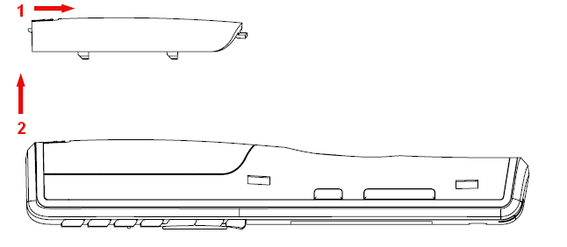

Handset Serial Number
The serial number (IPEI/IPUI number) of each handset is found either on a label, which is placed behind the battery, or on the packaging label. First, lift off handset back cover and lift the battery and read the serial number.
The serial number is needed to enable service to the handset. It must be programmed into the system database via the VoIP Configuration interface.

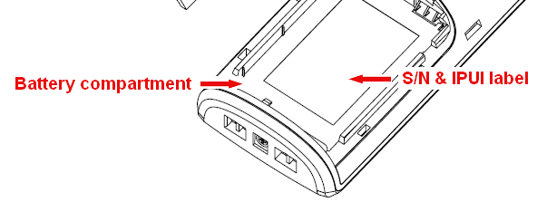
Replace Battery
Remove Back Cover from Handset. Remove the old battery and replace with a new one.

Using the Handset
Please refer handset manual for detailed description of how to use the handset features [1].

VoIP Administration Interface

The VoIP Administration Interface is the main interface through which the system is managed and debugged.

The VoIP Configuration Interface is an in-built HTTP Web Server service residing in each base station. This interface is user friendly interface and easy to handle even to a first time user.

Note: Enabling secure web is not possible. For secure configuration use secure provisioning.

This chapter seeks to define various variables/parameters available for configuration in the network.

Web navigation

We describe the left menu in the front end of the VoIP Administration Interface.

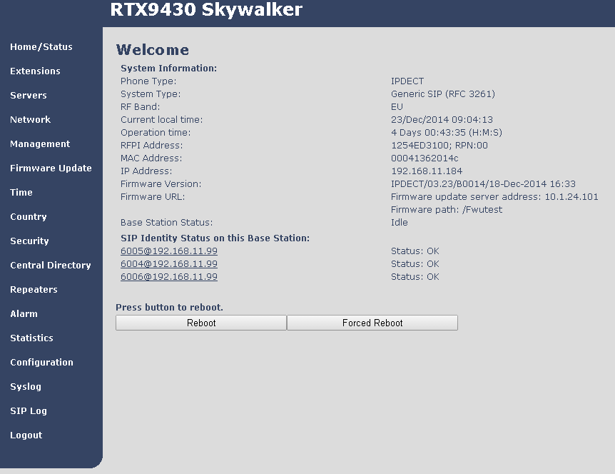

Feature | Description
Home/Status | This is the front end of the Base station’s HTTP web interface. This page shows the summary of current operating condition and settings of the Base station and Handset(s).
Extensions | Administration of extensions and handsets in the system
Servers | On this page the user can define which SIP/NAT server the network should connect to.
Network | Typically the user configures the Network settings from here.  NAT provisioning: allows configuration of features for resolving of the NAT – Network Address Translation. These features enable interoperability with most types of routers.  DHCP: allows changes in protocol for getting a dynamic IP address.  Virtual LAN: specifies the Virtual LAN ID and the User priority.  IP Mode: specifies using dynamic (DHCP) or static IP address for your network. IP address: if using DHCP leave it empty. Only write in, when you use static IP address.  Subnet mask: if using DHCP, leave it empty. Only write in, when you use static IP address.  DNS server: specify if using DHCP, leave it empty. Only write in the DNS server address of your Internet service provider, when you use static IP address. (DNS = Dynamic Name Server)  Default gateway: if using DHCP, leave it empty. Write in the IP address of your router, when you use static IP address.
Management | Defines the Configuration server address, Management transfer protocol, sizes of logs/traces that should be catalogued in the system.
Firmware Update | Remote firmware updates (HTTP(s)/TFTP) settings of Base stations and handsets.
Time | Here the user can configure the Time server. It should be used as time server in relevant country for exact time. The time servers have to deliver the time to conform to the Network Time Protocol (NTP). Handsets are synchronised to this time. Base units synchronise to the master using the Time server.
Country | Specifying the country/territory where the network is located ensures that your phone connection functions properly.  Note: The base language and country setting are independent of each other.
Security | The users can administrate certificates and create account credentials with which they can log in or log out of the embedded HTTP web server.
Central Directory | Interface to common directory load of up to 3000 entries using *csv format or configuration of LDAP directory.  Note: LDAP and central directory cannot operate at the same time.
Repeaters | Administration and configuration of repeaters of the system
Alarm | Administration and configuration of the alarm settings on the system. This controls the settings for alarms that can be sent to the handsets. This feature is only available on certain types of handsets.
Statistics | Overview of system and call statistics for a system.
Configuration | This shows detail and complete network settings for base station(s), HTTP/DNS/DHCP/TFTP server, SIP server, etc.
Syslog | Overall network related events or logs are displayed here (only live feed is shown).
SIP Log | SIP related logs can be retrieved from url link. It is also possible to clear logs from this feature.

Home/Status
We describe the parameters found in the Welcome front end home/status of the VoIP Administration Interface.

Screenshot
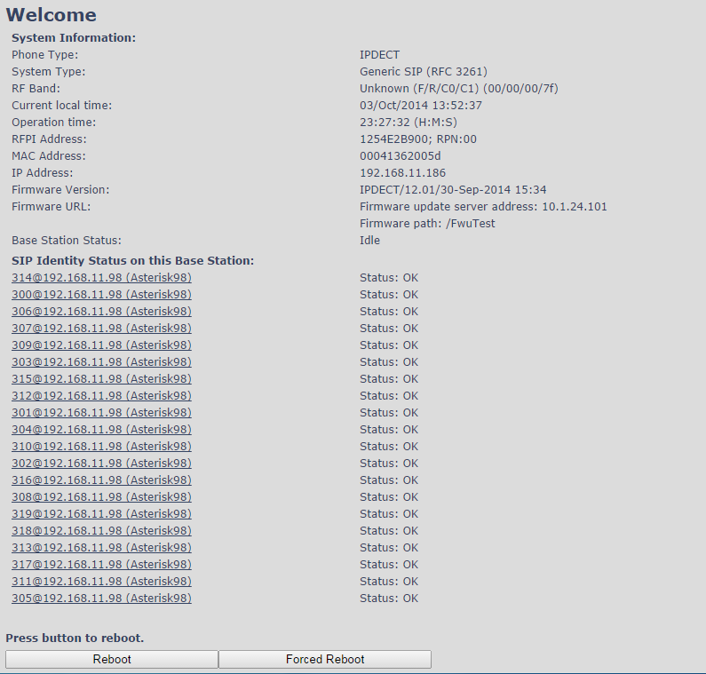

Parameter | Description
System information | This base current multi-cell state
Phone Type | Always IPDECT
System Type | This base customer configuration
RF Band | This base RF band setting
Current local time | This base local time
Operation time | Time from last boot of base
RFPI-Address | This base RFPI address
MAC-Address | This base MAC address
IP-Address | This base IP address
Firmware version | This base firmware version
Firmware URL | Firmware update server address and firmware path on server
Base Station Status | “Idle” : When no calls on base  “In use” : When active calls on base
SIP Identity Status on this Base Station | List of extensions present at this base station.  Format: “extension”@“this base IP address” followed by status to the right. Below is listed possible status:  OK: Handset is ok  SIP Error: SIP registration error
Reboot | Reboot after all connections is stopped on base. Connections are active call, directory access, firmware update active
Forced Reboot | Reboot immediately even active calls are ongoing.

Extensions

In this section, we describe the different parameters available whenever the administrator is creating extensions for handsets. Note, it is not possible to add extensions if no servers are defined. As well the section describes the group call feature.

The system can handle maximum 20 extensions matching 20 handsets which can be divided between servers. When 20 handsets are registered it is not possible to add more extensions.

Note: Within servers or even with multi servers, extensions must always be unique. This means same extension number on server 1 cannot be re-used on server 2.

Group call
Call Group is a SIP extension where multiple handsets are associated. All handsets that subscribes to a given extension (and hence Call Group) can receive incoming calls and initiate outgoing calls on the given extension. It is possible for any handset to perform any call action which is possible without the Call Group feature. That is, call actions as Hold, Transfer etc. are possible if the PBX supports them.

When an incoming call arrives to a given Call Group, all Call Group subscribed handsets will alert. Thus, if a Call Group contains 20 handsets, all 20 handset will alert.
An alerting handset cannot receive another incoming call, and therefore if a handset subscribes for multiple Call Groups, and a call arrives for a 2nd Call Group while the handset is alerting, the handset will not receive this call. If DND is enabled for a given handset, it will not receive the incoming call.

For outgoing calls, it can be selected in the handset which line (i.e. Call Group) to use for the call. The maximum number of lines is 20. For any outgoing actions, the settings for the selected line (SIP extension) will be used.

Add extension
Screenshot
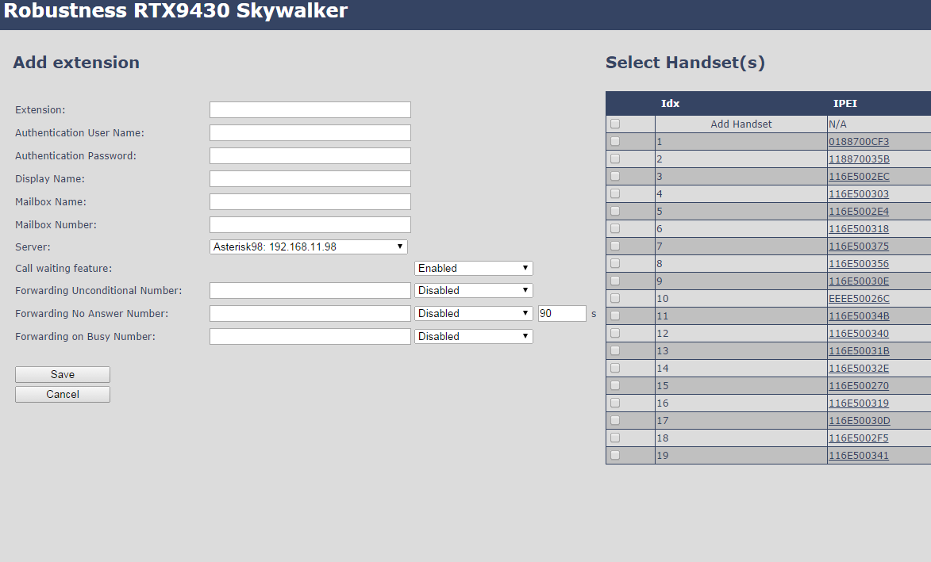

Parameter | Default Value(s) | Description
Extension | Empty | Handset phone number depending on the setup.  Possible value(s): 8-bit string length  Example: 1024, etc.  Note: The Extension must also be configured in SIP server in order for this feature to function.
Authentication User Name | Empty | Username: SIP authentication username  Permitted value(s): 8-bit string length
Authentication Password | Empty | Password: SIP authentication password.  Permitted value(s): 8-bit string length
Display Name | Empty | Human readable name used for the given extension  Permitted value(s): 8-bit string length
Mailbox Name | Empty | Name of centralised system used to store phone voice messages that can be retrieved by recipient at a later time.  Valid Input(s): 8-bit string Latin characters for the Name
Mailbox Number | Empty | Dialled mail box number by long key press on key 1.  Valid Input(s): 0 – 9, *, #  Note: Mailbox Number parameter is available only when it’s enabled from SIP server.
Server | Server 1 IP | FQDN or IP address of SIP server.  Drop down menu to select between the defined Servers of VoIP Service provider.
Call waiting feature | Enabled | Used to enable/disable Call Waiting feature. When disabled a second incoming call will be rejected. If enabled a second call will be presented as call waiting.
Forwarding Unconditional Number | Empty | Number to which incoming calls must be re-routed to irrespective of the current state of the handset.  Forwarding Unconditional must be enabled to function.  Note: Feature must be enabled in the SIP server before it can function in the network  Note: Feature will be automatically disabled in case the handset or extension is part of a group
 | Disabled
Forwarding No Answer Number | Empty | Number to which incoming calls must be re-routed to when there is no response from the SIP end node.  Forwarding No Answer Number must be enabled to function.  Note: Feature must be enabled in the SIP server before it can function in the network  Specify delay from call to forward in seconds.  Note: Feature will be automatically disabled in case the handset or extension is part of a group
 | Disabled
 | 90
Forwarding On Busy Number | Empty | Number to which incoming calls must be re-routed to when SIP node is busy.  Forwarding On Busy Number must be enabled to function.  Note: Feature must be enabled in the SIP server before it can function in the network  Note: Feature will be automatically disabled in case the handset or extension is part of a group
 | Disabled

When an extension is added (or edited) it can be selected (right side check box) which handsets shall subscribe to the given extension, and hence be a part of this call group, see above figure. It is also possible to choose to add a new handset entry at this point, and if this is done, DECT registration for the new entry can be enabled afterwards on the handsets subpage

Extensions list
The added extensions will be shown in the extension lists.
The list can be sorted by any of the top headlines, by mouse click on the headline link.

Screenshot
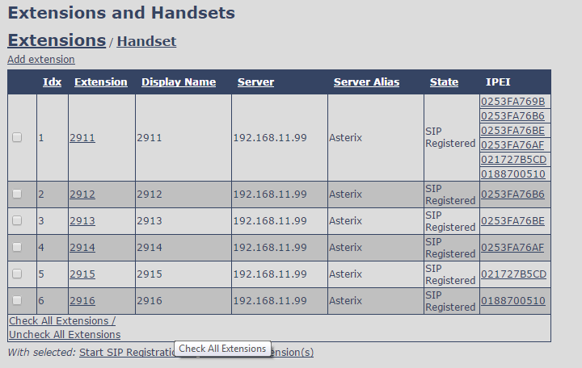

Parameter | Description
Idx | Select / deselect for delete, register and deregister handsets
Extension | Given extension is displayed.
Display Name | Given display name is displayed. If no name given this field will be empty
Server | Server IP or URL
Server Alias | Given server alias is displayed. If no alias given this field will be empty.
State | SIP registration state – if empty the handset is not SIP registered.
IPEI | Handset IPEI. IPEI is a unique DECT identification number.  Group call: One extension can be associated to up to 20 IPEI’s. The IPEI’s will be listed in this cell.

Handset list
The added handsets will be shown in the handset lists.
The list can be sorted by any of the top headlines, by mouse click on the headline link.

Screenshot
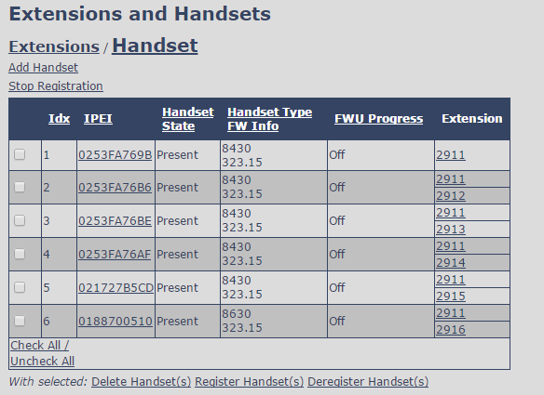

Parameter | Description
Idx | Select / deselect for delete, register and deregister handsets
IPEI | Handset IPEI. IPEI is unique DECT identification number.
Handset state | The state of the given handset:  Present: The handset is DECT located at the base  Detached: The handset is detached from the system (e.g. powered off)  Removed: The handset has been out of sight for a specified amount of time (~one hour).
Handset Type  FW info | Handset type and firmware version of handset
FWU Progress | Possible FWU progress states:  Off: Means sw version is specified to 0 = fwu is off  Initializing: Means FWU is starting and progress is 0%.  X% : FWU ongoing  Verifying X%: FWU writing is done and now verifying before swap  ”Waiting for charger” (HS) / ”Conn. term. wait” (Repeater): All FWU is complete and is now waiting for handset/repeater restart.  Complete HS/repeater: FWU complete  Error: Not able to fwu e.g. file not found, file not valid etc
Extension | Given extension is displayed.  Group call: The cell will show all the extensions associated with this handset and IPEI.

Handset and extension list top/sub-menus
The handset extension list menu is used to control paring or deletion of handset to the system (DECT registration/de-registrations) and to control SIP registration/de-registrations to the system.
Above and below the list are found commands for making operations on handsets/and extensions. The top menu is general operations, and the sub menu is always operating on selected handsets/extensions.

Screenshots

In the below table each command is described.

Actions | Description
Add extension | Access to the “Add extension” sub menu
Stop Registration | Manually stop DECT registration mode of the system. This prevents any handset from registering to the system
Delete Handset(s) | Deregister selected handset(s), but do not delete the extension(s).
Register Handset(s) | Enable registration mode for the system making it possible to register at a specific extension (selected by checkbox)
Deregister Handset(s) | Deregister the selected handset(s) and delete the extension(s).

Edit Extension
To edit extension use the mouse to click the link of the extension.
Edit extension will open the same configuration possibilities as add extension. Refer to the above add extension section.

Servers

In this section, we describe the different parameters available in the Servers configurations menu.
Maximum 10 servers can be configured.

Screenshot
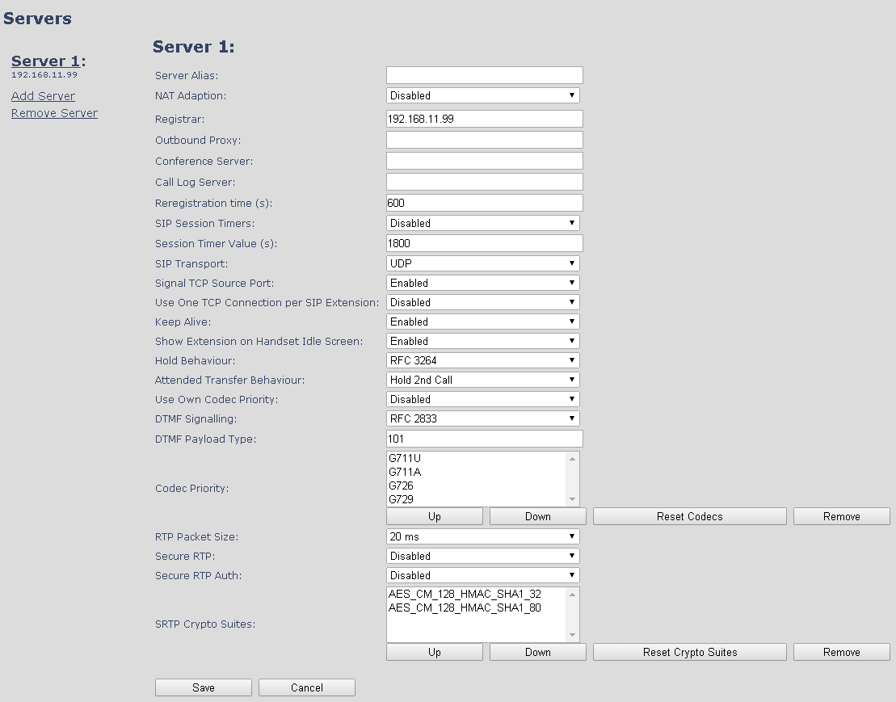

Parameter | Default value | Description
Server Alias | Empty | Parameter for server alias
NAT Adaption | Disabled | To ensure all SIP messages goes directly to the NAT gateway in the SIP aware router.
Registrar | Empty | SIP Server proxy DNS or IP address  Permitted value(s): AAA.BBB.CCC.DDD:<Port-Number> or <URL>:<Port-Number>  Note: Specifying the Port Number is optional.
Outbound Proxy | Empty | This is a Session Border Controller DNS or IP address (OR SIP server outbound proxy address)  Set the Outbound proxy to the address and port of private NAT gateway so that SIP messages sent via the NAT gateway.  Permitted value(s): AAA.BBB.CCC.DDD or <URL> or <URL>:<Port-Number>  Examples: “192.168.0.1”, “192.168.0.1:5062”,  “nat.company.com” and “sip:nat@company.com:5065”.
Conference Server | Empty | Broadsoft conference feature.  Set the IP address of the conference server.  In case an IP is specified pressing handset conference will establish a connection to the conference server.  If the field is empty the original 3-party local conference of 8660 is used.
Call Log Server | Empty | Broadsoft call log feature.  Set the IP address of the XSI call log server.  In case an IP is specified pressing handset will use the call log server.  If the field is empty the local call log is used
Re-registration time | 600 | The “expires” value nalysen in SIP REGISTER requests. This value indicates how long the current SIP registration is valid, and hence is specifies the maximum time between SIP registrations for the given SIP account.  Permitted value(s): A value below 60 sec is not recommended, Maximum value 65636
SIP Session Timers: | Disabled | RFC 4028. A “keep-alive” mechanism for calls. The session timer value specifies the maximum time between “keep-alive” or more correctly session refresh signals. If no session refresh is received when the timer expires the call will be terminated. Default value is 1800 s according to the RFC. Min: 90 s. Max: 65636.  If disabled session timers will not be used.
Session Timer Values (s): | 1800 | Default value is 1800s according to the RFC.  If disabled session timers will not be used.  Permitted value(s): Minimum value 90, Maximum 65636
SIP Transport | UDP | Select UDP, TCP, TLS 1.0
Signal TCP Source Port | Disabled | When SIP Transport is set to TCP or TLS, a TCP (or TLS) connection will be established for each SIP extension. The source port of the connection will be chosen by the TCP stack, and hence the local SIP port parameter, specified within the SIP/RTP Settings (see 5.5.5) will not be used. The “Signal TCP Source Port” parameter specifies if the used source port shall be signaled explicitly in the SIP messages.
Use One TCP/TLS Connection per SIP Extension: | Disabled | When using TCP or TLS as SIP transport, choose if a TCL/TLS connection  shall be established for each SIP extension or if the base station shall establish one connection which all SIP extensions use. Please note that if TLS is used and SIP server requires client authentication (and requests a client certificate), this setting must be set to disabled.  0: Disabled. (Use one TCP/TLS connection for all SIP extensions)  1: Enabled. (Use one TCP/TLS connection per SIP extensions).
Keep Alive | Enabled | This directive defines the window period (30 sec.) to keep opening the port of relevant NAT-aware router(s), etc.
Show Extension on Handset Idle Screen | Enabled | If enabled extension will be shown on handset idle screen.
Hold Behaviour | RFC 3264 | Specify the hold behaviour by handset hold feature.  RFC 3264: Hold is nalysen according to RFC 3264, i.e. the connection information part of the SDP contains the IP Address of the endpoint, and the direction attribute is sendonly, recvonly or inactive dependant of the context  RFC 2543: The ”old” way of nalyseng HOLD. The connection information part of the SDP is set to 0.0.0.0, and the direction attribute is sendonly, recvonly or inactive dependant of the context
Attended Transfer Behaviour | Hold 2nd Call | When we have two calls, and one call is on hold, it is possible to perform attended transfer. When the transfer soft key is pressed in this situation, we have traditionally also put the active call on hold before the SIP REFER request is sent. However, we have experienced that some PBXes do not expect that the 2nd call is put on hold, and therefore attended transfer fails on these PBXes.  The "Attended Transfer Behaviour" feature defines whether or not the 2nd call shall be put on hold before the REFER is sent.  If "Hold 2nd Call" is selected, the 2nd call will be held before REFER is sent.  If "Do Not Hold 2nd Call" is selected, the 2nd call will not be held before the REFER is sent
Use Own Codec Priority | Disabled | Default disabled.  By enable the system codec priority during incoming call is used instead of the calling party priority.  E.g. If base has G722 as top codec and the calling party has Alaw on top and G722 further down the list, the G722 will be chosen as codec for the call.
DTMF Signalling | RFC 2833 | Conversion of decimal digits (and ‘*’ and ‘#’) into sounds that share similar characteristics with voice to easily traverse networks designed for voice  SIP INFO: Carries application level data along SIP signalling path (e.g.: Carries DTMF digits generated during SIP session OR sending of DTMF tones via data packets in the same internet layer as the Voice Stream, etc.).  RFC 2833: DTMF handling for gateways, end systems and RTP trunks (e.g.: Sending DTMF tones via data packets in different internet layer as the voice stream)  Both: Enables SIP INFO and RFC 2833 modes.
DTMF Payload Type | 101 | This feature enables the user to specify a value for the DTMF payload type / telephone event (RFC2833).
Codec Priority | G.711U  G.711A  G.726 | Defines the codec priority that base stations uses for audio compression and transmission.  Possible Option(s): G.711U,G.711A, G.726, G.729, G.722.  Note: Modifications of the codec list must be followed by a “reset codes” and “Reboot chain” on the multipage in order to change and update handsets.  Note:  With G.722 as first priority the number of simultaneous calls per base station will be reduced from 10 (8) to 4 calls.  With G.722 in the list the codec negotiation algorithm is active causing the handset (phone) setup time to be slightly slower than if G.722 is removed from the list.  With G.729 add on DSP module for the base is required. Contact RTX sales for purchase number 96101203.
RTP Packet size | 20ms | The packet size offered as preferred RTP packet size by 8630 when RTP packet size negotiation.  Selections available: 20ms, 40ms, 60ms, 80ms
Secure RTP | Disabled | With enable RTP will be encrypted (AES-128) using the key negotiated via the SDP protocol at call setup.
Secure RTP Auth | Disabled | With enable secure RTP is using authentication of the RTP packages.  Note: with enabled SRTP authentication maximum 4 concurrent calls is possible per base in a single or multicell system.
SRTP Crypto Suites | AES_CM_128_HMAX_SHA1_32  AES_CM_128_HMAX_SHA1_80 | Field list of supported SRTP Crypto Suites. The device is born with two suites.

Note: Within servers or even with multi servers, extensions must always be unique. This means same extension number on server 1 cannot be re-used on server 2.

Network

In this section, we describe the different parameters available in the network configurations menu.

IP Settings
Screenshot
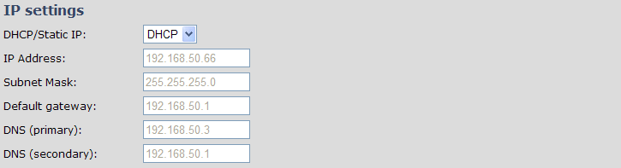

Parameter | Default Values | Description
DHCP/Static IP | DHCP | If DHCP is enabled, the device automatically obtains TCP/IP parameters.  Possible value(s): Static, DHCP  DHCP: IP addresses are allocated automatically from a pool of leased address.  Static IP: IP addresses are manually assigned by the network administrator.  If the user chooses DHCP option, the other IP settings or options are not available.
IP Address | NA | 32-bit IP address of device (e.g. base station). 64-bit IP address will be supported in the future.  Permitted value(s): AAA.BBB.CCC.DDD
Subnet Mask | NA | Is device subnet mask.  Permitted value(s): AAA.BBB.CCC.DDD  This is a 32-bit combination used to describe which portion an IP address refers to the subnet and which part refers to the host.  A network mask helps users know which portion of the address identifies the network and which portion of the address identifies the node.
Default Gateway | NA | Device’s default network router/gateway (32-bit).  Permitted value(s): AAA.BBB.CCC.DDD e.g. 192.168.50.0  IP address of network router that acts as entrance to other network. This device provides a default route for TCP/IP hosts to use when communicating with other hosts on hosts networks.
DNS (Primary) | NA | Main server to which a device directs Domain Name System (DNS) queries.  Permitted value(s): AAA.BBB.CCC.DDD or <URL>  This is the IP address of server that contains mappings of DNS domain names to various data, e.g. IP address, etc.  The user needs to specify this option when static IP address option is chosen.
DNS (Secondary) | NA | This is an alternate DNS server.

VLAN Settings
Enable users to define devices (e.g. Base station, etc.) with different physical connection to communicate as if they are connected on a single network segment.

The VLAN settings can be used on a managed network with separate Virtual LANs (VLANs) for sending voice and data traffic. To work on these networks, the base stations can tag voice traffic it generates on a specific “voice VLAN” using the IEEE 802.1q specification.

Screenshot
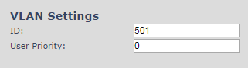

Parameter | Default Values | Description
VLAN id | 0 | Is a 12 bit identification of the 802.1Q VLAN.  Permitted value(s): 0 to 4094 (only decimal values are accepted)  A VLAN ID of 0 is used to identify priority frames and ID of 4095 (i.e. FFF) is reserved.  Null means no VLAN tagging or No VLAN discovery through DHCP.
VLAN User Priority | 0 | This is a 3 bit value that defines the user priority.  Values are from 0 (best effort) to 7 (highest); 1 represents the lowest priority. These values can be used to prioritize different classes of traffic (voice, video, data, etc).  Permitted value(s): 8 priority levels (i.e. 0 to 7)

For further help on VLAN configuration refer to Appendix.

DHCP Options
Screenshot

Parameter | Default Values | Description
Plug-n-Play | Disabled | Enabled: DHCP option 43 to automatically provide PBX IP address to base.

NAT Settings
We define some options available when NAT aware routers are enabled in the network.

Screenshot
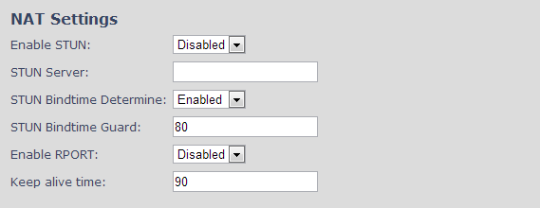

Parameter | Default Values | Description
Enable STUN | Disabled | Enable to use STUN
STUN Server | NA | Permitted value(s): AAA.BBB.CCC.DDD (Currently only Ipv4 are supported) or url (e.g.: firmware.rtx.net).
STUN Bindtime Determine | Enabled
STUN Bindtime Guard | 80 | Permitted values: Positive integer default is 90, unit is in seconds
Enable RPORT | Disabled | Enable to use RPORT in SIP messages.
Keep alive time | 90 | This defines the frequency of how keep-alive are sent to maintain NAT bindings.  Permitted values: Positive integer default is 90, unit is in seconds

SIP/RTP Settings
These are some definitions of SIP/RTP settings:

Screenshot
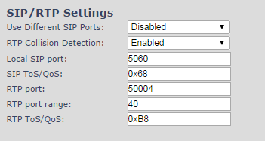

Parameter | Default Values | Description
Use Different SIP Ports | Disabled | If disabled, the Local SIP port parameter specifies the source port used for SIP signalling in the system.  If enabled, the Local SIP Port parameter specifies the source port used for first user agent (UA) instance. Succeeding UA’s will get succeeding ports.
RTP Collision Detection | Enabled
Local SIP port | 5060 | The source port used for SIP signalling  Permitted values: Port number default 5060.
SIP ToS/QoS | 0x68 | Priority of call control signalling traffic based on both IP Layers of Type of Service (ToS) byte. ToS is referred to as Quality of Service (QoS) in packet based networks.  Permitted values: Positive integer, default is 0x68
RTP port | 50004 | The first RTP port to use for RTP audio streaming.  Permitted values: Port number default 50004 (depending on the setup).
RTP port range | 40 | The number of ports that can be used for RTP audio streaming.  Permitted values: Positive integers, default is 40
RTP TOS/QoS | 0xB8 | Priority of RTP traffic based on the IP layer ToS (Type of Service) byte. ToS is referred to as Quality of Service (QoS) in packet based networks.  See RFC 1349 for details. “cost bit” is not supported.  o Bit 7..5 defines precedence.  o Bit 4..2 defines Type of Service.  o Bit 1..0 are ignored.  Setting all three of bit 4..2 will be ignored.  Permitted values: Positive integer, default is 0xB8

Management Settings Definitions

The administrator can configure base stations to perform some specific functions such as configuration of file transfers, firmware up/downgrades, password management, and SIP/debug logs.

Screenshot

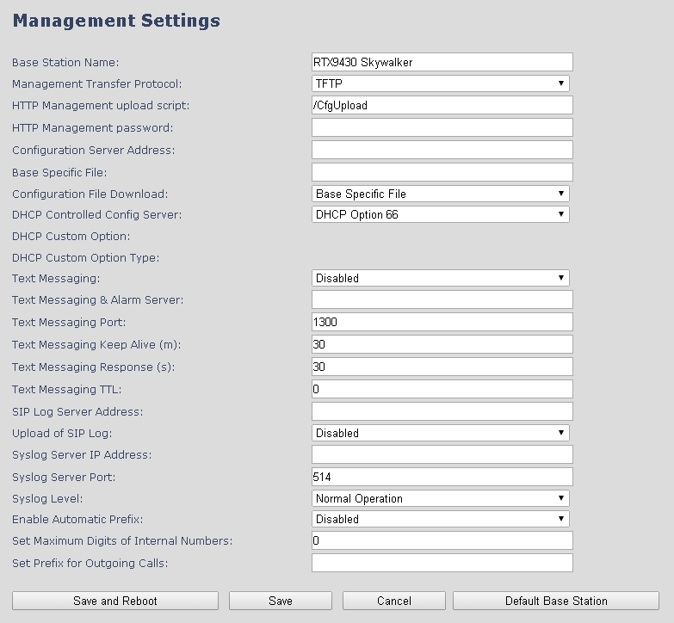

Parameter | Default value | Description
Base Station Name: | VoIP | It indicates the title that appears at the top window of the browser and is used in the multicell page.
Management Transfer Protocol | TFTP | The protocol assigned for configuration file and central directory  Valid Input(s): TFTP, HTTP, HTTPs
HTTP Management upload script | Empty | The folder location or directory path that contains the configuration files of the Configuration server. The configuration upload script is a file located in e.g. TFTP server or Apache Server which is also the configuration server.  Permitted value(s): /<configuration-file-directory>  Example: /CfgUpload  Note: Must begin with (/) slash character. Either / or \ can be used.
HTTP Management password | Empty | Password that should be entered in order to have access to the configuration server.  Permitted value(s): 8-bit string length
Configuration server address | Empty | Server/device that provides configuration file to base station.  Type: DNS or IP address  Permitted value(s): AAA.BBB.CCC.DDD or <URL>
Base Specific File | Empty | Base configuration file
Configuration File Download | Disabled | Base Specific file: Used when configuring a single cell base  Multicell Specific File: Used when configuring a multicell based system  Base and Multicell Specific File: Used on out of factory bases to specify VLAN and Multicell ID and settings.
DHCP Controlled Config Server | Disabled | Provisioning server options.  DHCP Option 66: Look for provision file by TFTP boot up server.  DHCP Custom Option: Look for provision file by custom option  DHCP Custom Option & Option 66: Look for provision file by first custom option and then option 66.
DHCP Custom Option | Empty | By default option 160, but custom option can be defined.  An option 160 URL defines the protocol and path information by using a fully qualified domain name for clients that can use DNS.
DHCP Custom Option Typr | Empty | URL: URL of server with path.  Example of URL: http://myconfigs.com:5060/configs  Default configuration file on server must follow the name: MAC.cfg  IP Address: IP of server with path.
Text Messaging | Disabled | Disable/enable messaging with Mobicall server  The third option is to “Enable Without Server”. With this setting handset can send messages to other handsets, which support messaging.  Note: Contact Mobicall to get the proper version and setup for Mobicall server
Text Messaging & Alarm server | Empty | Permitted value(s): AAA.BBB.CCC.DDD or <URL>
Text Messaging Port | 1300 | Port number of message server.
Text Messaging Keep Alive (m) | 30 | This defines the frequency of how keep-alive are sent  Permitted values: Positive integer, unit is in minutes
Text Messaging Response (s) | 30 | This defines the frequency of how response timeout  Permitted values: Positive integer, unit is in seconds
Text Messaging TTL | 0 | This defines the text messaging time to live  Permitted values: Positive integer, unit is in seconds
SIP Log Server Address | Empty | Permitted value(s): AAA.BBB.CCC.DDD or <URL>  Requires a predefined folder named: \SIP
Upload of SIP Log | Disabled | Enable this option to save low level SIP debug messages to the server. The SIP logs are saved in the file format: <MAC_Address><Time_Stamp>SIP.log
Syslog Server IP-Address | NA | Permitted value(s): AAA.BBB.CCC.DDD or <URL>
Syslog Server Port | NA | Port number of syslog server.
Syslog Level | Off | Off: No data is saved on syslog server  Normal Operation: Normal operation events are logged, incoming call, outgoing calls, handset registration, DECT location, and call lost due to busy, critical system errors, general system information.  System Analyze: Handset roaming, handset firmware updates status. The system nalyse level also contains the messages from normal operation.  Debug: Used by RTX for debug. Should not be enabled during normal operation.
Enable Automatic Prefix | Disabled | Disabled: Feature off.  Enabled: The base will add the leading digit defined in “Set Prefix for Outgoing Calls”.  Enabled + fall through on * and #: Will enable detection of * or # at the first digit of a dialled number. In case of detection the base will not complete the dialled number with a leading 0.  Examples:  1: dialed number on handset * 1234 - > dialed number to the pabx *1234  2: dialed number on handset #1234 - > dialed number to the pabx #1234  3: dialed number on handset 1234 - > dialed number to the pabx 01234
Set Maximum Digits of Internal Numbers | 0 | Used to detect internal numbers. In case of internal numbers no prefix number will be added to the dialled number.
Set Prefix for Outgoing Calls | Empty | Prefix number for the enabled automatic prefix feature.  Permitted value(s): 1 to 9999

There are three ways of configuring the system.
1. Manual configuration by use of the Web server in the base station(s)
2. By use of configuration files that are uploaded from a disk via the “Configuration” page on the Web server.
3. By use of configuration files which the base station(s) download(s) from a configuration server.

For further details refer to doc reference [3].

Firmware Update Definitions

In this page, the system administrator can configure how base stations and SIP nodes upgrade/downgrade to the relevant firmware. Handset firmware update status can be found in the extensions page and repeater firmware update status in the repeater page. Base firmware update status is found in the multicell page.

Screenshot
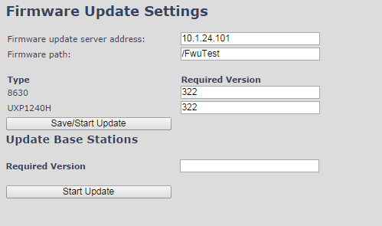

Parameter | Default Value(s) | Description
Firmware update server address | Empty | IP address or DNS of firmware update files source  Valid Inputs: AAA.BBB.CCC.DDD or <URL>  Example: firmware.rtx.net or 10.10.104.41
Firmware path | Empty | Location of firmware on server (or firmware update server path where firmware update files are located).  Example: /East_Fwu  Note: Must begin with (/) slash character
Required Version Type | Empty | Version of firmware to be upgraded (or downgraded) on handset type or repeater.  Valid Input(s): 8-bit string length. E.g. 280  Note: Value version 0 will disable firmware upgrade for handsets and/or repeater  Note: Two handset types will be serial firmware upgraded. First type 8630 then type 8430.
Required Version  Base | Empty | Version of firmware to be upgraded (or downgraded) on Base station. Base units are referred to as gateways over here.  Valid Input(s): 8-bit string length. E.g. 280

Time Server

In this section, we describe the different parameters available in the Time Server menu.
The Time server supplies the time used for data synchronisation in a multi-cell configuration. As such it is mandatory for a multi-cell configuration. The system will not work without a time server configured.

As well the time server is used in the debug logs and for SIP traces information pages, and used to determine when to check for new configuration and firmware files.

NOTE: It is not necessary to set the time server for standalone base stations (optional).

Press the “Time PC” button to grab the current PC time and use in the time server fields.

NOTE:
When time server parameters are modified/changed synchronisation between base stations can take up to 15 minutes before all base stations are synchronised, depending on the number of base stations in the system.

Screenshot
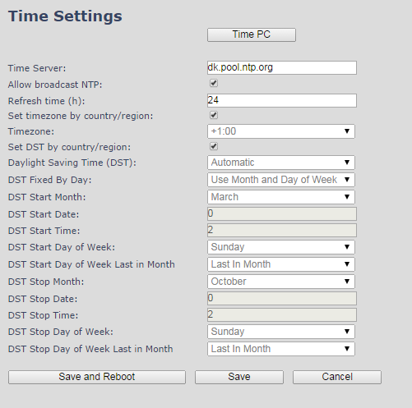

Parameter | Default Values | Description
Time Server | Empty | DNS name or IP address of NTP server.  Enter the IP/DNS address of the server that distributes reference clock information to its clients including Base stations, Handsets, etc.  Valid Input(s): AAA.BBB.CCC.DDD or URL (e.g. time.server.com)  Currently only Ipv4 address (32-bit) nomenclature is supported.
Allow broadcast NTP | Checked
Refresh time (h) | Empty | The window time in seconds within which time server refreshes.  Valid Inputs: positive integer
Set timezone by country/region | Checked | By checked country setting is used (refer to country web page).
Time Zone | 0 | Refers to local time in GMT or UTC format.  Min: -12:00  Max: +13:00
Set DST by country/region | Checked | By checked country setting is used (refer to country web page).
Daylight Saving Time (DST) | Disabled | The system administrator can Enable or Disable DST manually.  Automatic: Enter the start and stop dates if you select Automatic.
DST Fixed By Day | Use Month and Date | You determine when DST actually changes. Choose the relevant date or day of the week, etc. from the drop down menu.
DST Start Month | March | Month that DST begins  Valid Input(s): Gregorian months (e.g. January, February, etc.)
DST Start Date | 25 | Numerical day of month DST comes to effect when DST is fixed to a specific date  Valid Inputs: positive integer
DST Start Time | 3 | DST start time in the day  Valid Inputs: positive integer
DST Start Day of Week | Monday | Day within the week DST begins
DST Start Day of Week, Last in Month | Last in Month | Specify the week that DST will actually start.
DST Stop Month | October | The month that DST actually stops.
DST Stop Date | 1 | The numerical day of month that DST turns off.  Valid Inputs: positive integer (1 to 12)
DST Stop Time | 2 | The time of day DST stops  Valid Inputs: positive integer (1 to 12)
DST Stop Day of Week | Sunday | The day of week DST stops
DST Stop Day of Week Last in Month | First in Month | The week within the month that DST will turn off.

Country

The country setting controls the in-band tones used by the system. To select web interface language go to the management page.

Screenshot
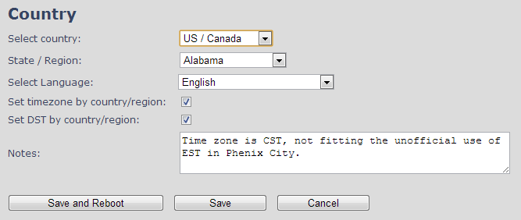

Parameter | Default Values | Description
Select Country | Germany | Supported countries: Australia, Belgium, Brasil, Denmark, Germany, Spain, France, Ireland, Italia, Luxembourg, Nederland, New Zealand, Norway, Portugal, Swiss, Finland, Sweden, Tyrkey, United Kingdom, US/Canade, Austria
State / Region | NA | Only shown by country selection US/Canada, Autralia, Brasil
Select Language | English | Web interface language. Number of available languages: English, Dansk, Italiano, Tyrkie, Deutsch, Portuguese, Hrvatski, Srpski, Slovenian, Nederlands, Francaise, Espanol, Russian, Polski.
Set timezone by country/region | checked | When checked timezone will follow country/region
Set DST by country/region | checked | When checked DST will follow country/region
Notes | Empty | Only showing notes to time setting for countries: US/Canada, Brasil

NOTE: By checked timezone and DST the parameters in web page Time will be discarded.

The following types of in-band tones are supported:
- Dial tone
- Busy tone
- Ring Back tone
- Call Waiting tone
- Re-order tone

Security

The security section is used for loading of certificates and for selecting if only trusted certificates are used. Furthermore, web password can be configured.
The Security web is divided into three sections: Certificates (trusted), SIP Client Certificates (and keys) and Password administration.

To setup secure fwu and configuration file download select HTTPs for the Management Transfer Protocol (refer to management web).

SIP and RTP security is server dependent and in order to configure user must use the web option Servers (refer to servers web).

Certificates
The certificates list contains the list of loaded certificates for the system. Using the left column check mark it is possible to check and delete certificates. To import a new certificate use the mouse “select file” and browse to the selected file. When file is selected, use the “Load” bottom to load the certificate.
The certificate format supported is DER encoded binary X.509 (.cer).

Screenshot
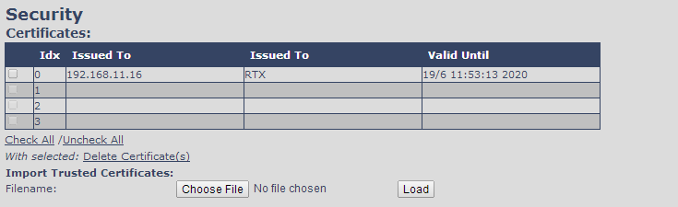

Certificates list
Parameter | Default Values | Description
Idx | Fixed indexes | Index number
Issued To | Empty | IP address – which is part of the certificate file
Issued To | Empty | Organisation, Company – which is part of the certificate file
Valid Until | Empty | Date Time Year – which is part of the certificate file

Screenshot

By enabling Use Only Trusted Certificates, the certificates the base will receive from the server must be valid and loaded into the system. If no valid matching certificate is found during the TLS connection establishment, the connection will fail. When Use Only Trusted Certificates is disabled, all certificates received from the server will be accepted.
Note: It is important to use correct date and time of the system when using trusted certificates. In case of time/date not defined the certificate validation can fail

SIP Client Certificates
To be able to establish a TLS connection in scenarios, where the server requests a client certificate, a certificate/key pair must be loaded into the base. This is currently supported only for SIP.
To load a client certificate/key pair, both files must be selected at the same time, and it is done by pressing “select files” under “Import SIP Client Certificate and Key Pair” and then select the certificate file as well as the key file at the same time. Afterwards, press load.
The certificate must be provided as a DER encoded binary X.509 (.cer) file, and the key must be provided as a binary PKCS#8 file.

Note: Use Chrome for loading SIP Client Certificates

Screenshot
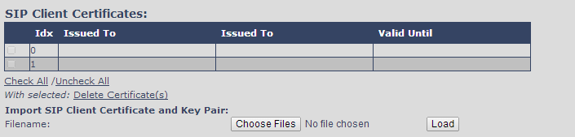

Password

In the below the password parameters are defined.

Screenshot

Parameter | Default Values | Description
Username | Admin | Can be modified to any supported character and number
Current Password | Admin | Can be modified to any supported character and number
New Password | Empty | Change to new password
Confirm Password | Empty | Confirm password to reduce accidently wrong changes of passwords

Password valid special signs: @/|<>-_:.!?*+#
Password valid numbers: 0-9
Password valid letters: a-z and A-Z

Central Directory and LDAP

The VOIP system support two types of central directories, a local central directory or LDAP directory.

For both directories caller id look up is made with match for 6 digits of the phone number.

Local Central Directory
Select local and save for local central directory.

Screenshot
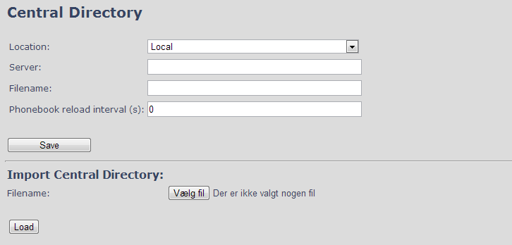

Parameter | Default Values | Description
Local | Local | Drop down menu to select between local central directory and LDAP based central directory
Server | Empty | The parameter is used if directory file is located on server.  Valid Inputs: AAA.BBB.CCC.DDD or <URL>  Refer to appendix for further details.
Filename | Empty | The parameter is used if directory file is located on server. Refer to appendix for further details
Phonebook reload interval (s) | 0 | The parameter is controlling the reload interface of phonebook in seconds. The feature is for automatic reload the base phonebook file from the server with intervals. It is recommended to specify a conservative value to avoid overload of the base station.  With default value setting 0 the reload feature is disabled.

Import Central Directory
The import central directory feature is using a browse file approach. After file selection press the load button to load the file. The system support only the original *.csv format. Please note that some excel csv formats are not the original csv format. The central directory feature can handle up to 3000 contacts. For further details of the central directory feature refer to appendix.

LDAP
Select LDAP Server and save for LDAP server configuration.

Screenshot
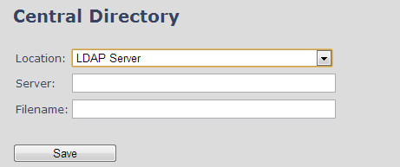

Screenshot
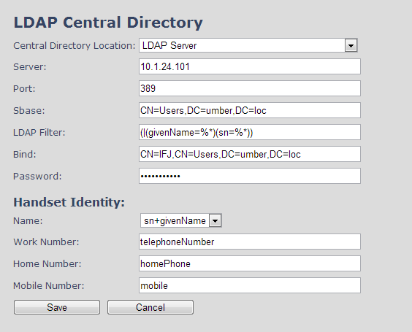

Parameter | Default Values | Description
LDAP Server | LDAP Server | Drop down menu to select between local central directory and LDAP based central directory. LDAP Server is displayed when LDAP server is selected.
Server | Empty | IP address of the LDAP server.  Valid Inputs: AAA.BBB.CCC.DDD or <URL>
Port | Empty | The server port number that is open for LDAP connections.
Sbase | Empty | Search Base. The criteria depends on the configuration of the LDAP server. Example of the setting is CN=Users, DC=umber, DC=loc
LDAP filter | Empty | LDAP Filter is used to as a search filter, e.g. setting LDAP filter to (|(givenName=%*)(sn=%*)) the IP-DECT will use this filter when requesting entries from the LDAP server. % will be replaced with the entered prefix e.g searching on J will give the filter (|(givenName=J*)(sn=J*)) resulting in a search for given name starting with a J or surname starting with J.
Bind | Empty | Bind is the username that will be used when the IP-DECT phone  connects to the server
Password | Empty | Password is the password for the LDAP Server
Name | Empty | The name can be used to specify if sn+givenName or cn (common name) is return in the LDAP search results
Work Number | Empty | Work number is used to specify that LDAP attribute that will be mapped to the handset work number
Home Number | Empty | Home number is used to specify that LDAP attribute that will be mapped to the handset home number
Mobile Number | Empty | Mobile number is used to specify that LDAP attribute that will be mapped to the handset mobile number

Repeaters
Within this section we describe the repeater parameter, and how to operate the repeater.

Add repeater
From repeaters web select “Add Repeater”

Screenshot
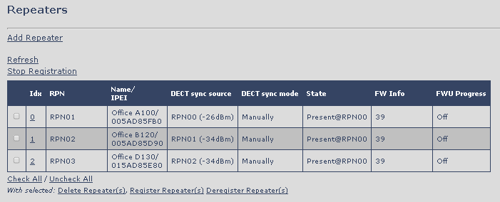

Then select “DECT Sync mode”

Screenshot
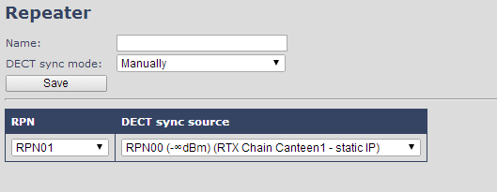

Parameters | Description
Name | Repeater name. If no name specified the field will be empty
DECT sync mode | Manually: User controlled by manually assign “Repeater RPN” and “DECT sync source RPN”  Local Automatical: Repeater controlled by auto detects best base signal and auto assign RPN.

Manually
User controlled by manually assign “Repeater RPN” and “DECT sync source RPN”. The parameters are selected from the drop down menu.

Screenshot

Parameters | Description
Idx | System counter
RPN | SINGLE CELL SYSTEM:  The base has always RPN00, first repeater will then be RPN01, second repeater RPN02 and third RPN03 (3 repeaters maximum per base)  MULTI CELL SYSTEM:  Bases are increment by 2^2 in hex, means first base RPN00 second base RPN04 etc., in between RPN01, 02, 03 addressed for repeaters at Primary base and 05, 06, 07 addressed for Secondary base (3 repeaters maximum per base)
DECT sync source | Select the base or repeater the repeater has to be synchronized to.

Local Automatical
Repeater controlled by auto detects best base signal and auto assign RPN. The RPN and DECT sync source are greyed out.

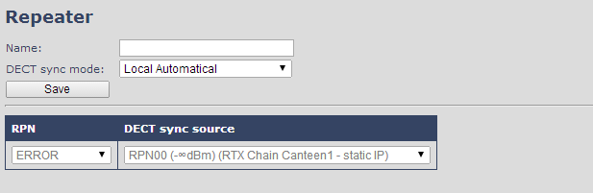

The repeater RPN is dynamic assigned in base RPN range.
With local automatical mode repeater on repeater (chain) is not supported.

Register Repeater

Adding a repeater makes it possible to register the repeater. Registration is made by select the repeater and pressing register repeater. The base window for repeater registration will be open until the registration is stopped. By stopping the registration all registration on the system will be stopped inclusive handset registration.

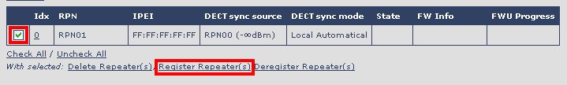

Repeaters list

Parameters | Description
IDx | Repeater unit identity in the chained network.  Permitted Output: Positive Integers
RPN | The Radio Fixed Part Number is an 8-bit DECT cell identity allocated by the installer. The allocated RPN within the must be geographically unique.  Permitted Output: 0 to 255 (DEC) OR 0x00 to 0xFF (HEX)
Name/IPEI | Contains the name and the unique DECT serial number of the repeater. If name is given the field will be empty.
DECT sync Source | The “multi cell chain” connection to the specific Base/repeater unit. Maximum number of chain levels is 12.  Sync. source format: “RPNyy (-zz dBm)”  yy: RPN of source  zz: RSSI level seen from the actual repeater
DECT sync Mode | Manually: User controlled by manually assign “Repeater RPN” and “DECT sync source RPN”  Local Automatical: Repeater controlled by auto detects best base signal and auto assign RPN.  Chaining Automatical: Base controlled by auto detects best base or repeater signal and auto assign RPN. This feature will be supported in a future version
State | Present@unit means connected to unit with RPN yy
FW info | Firmware version
FWU Progress | Possible FWU progress states:  Off: Means sw version is specified to 0 = fwu is off  Initializing: Means FWU is starting and progress is 0%.  X% : FWU ongoing  Verifying X%: FWU writing is done and now verifying before swap  ”Conn. term. wait” (Repeater): All FWU is complete and is now waiting for connections to stop before repeater restart.  Complete HS/repeater: FWU complete  Error: Not able to fwu e.g. file not found, file not valid etc

Alarm
In the Alarm Settings menu, it is controlled how an alarm appears on the handset. For example if the handset detects “Man Down”, then it is defined in this menu what alarm signal this type of alarm will send out and if a pre-alarm shall be signaled etc.

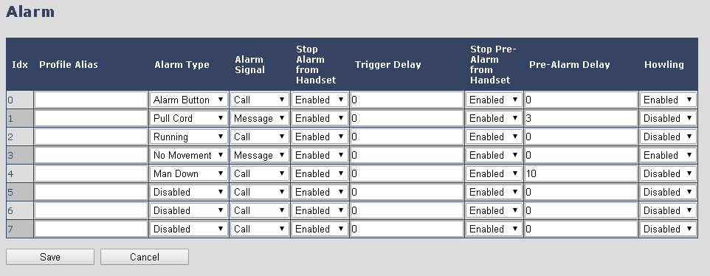

All configuration of the handset Alarm Settings is done from the base station. The concept is that on the “Alarm” page on the web server, eight different alarm profiles can be configured. Afterwards for each handset, it can be selected which of the configured alarm profiles, the given handset shall subscribe to. When this is done the selected alarm profiles are sent to the handset.
See section 5.3.2.3 Multiline: Edit handset

The parameters that can be configured are:

Parameters | Description
Idx | Indicates the index number of a specific alarm.
Profile Alias | An alias or user-friendly name to help identify the different profiles when selecting which profiles to enable for the individual handsets.
Alarm Type | The type of alarm is dependent of what kind of event that has triggered the alarm on the handset. The handset supports either of the following categories:  Man Down  No Movement  Running  Pull Cord  Emergency Button  Disabled
Alarm Signal | The way the alarm is signalled as it received on the handset.  Message: A text message to an alarm server.  Call: An outgoing call to the specified emergency number.
Stop Alarm from Handset | Enable/disable the possibility to stop/cancel the alarm from the handset.
Trigger Delay | The period from when the alarm has fired until the handset shows a pre-alarm warning. If set to 0, there will be no pre-alarm warning, and the alarm will be signalled immediately.
Stop Pre-Alarm from Handset | Enable/disable the possibility to stop/cancel the pre-alarm from the handset.
Pre-Alarm Delay | The period from the pre-alarm warning is shown until the actual alarm is signalled.
Howling | Enable/disable if howling shall be started in the handset, when the alarm is signalled. If disabled, only the configured signal is sent (call or message).

This alarm feature is only available on some types of handsets (e.g. the RTX8830)
After configuration, the handset must be rebooted.

Use of Emergency Alarms
As described above, it can be configured if it shall be possible to stop an alarm from the handset. If the possibility to stop an alarm from the handset is disabled, it is ensured that an alarm is not stopped before someone at e.g. an emergency center has received the alarm and reacted upon it.

The behavior of a handset when an alarm “is sent” depends on the configured Alarm Signal:
- Call: When the Alarm Signal is configured as “Call”, the handset will make a call to the specified emergency number, and the alarm is considered stopped when the call is terminated. If it is not allowed to stop the alarm from the handset, it will not be possible to terminate the call from handset, and the alarm will be considered as stopped only when the remote end (e.g. the emergency center) terminates the call.
- Message: When the Alarm Signal is configured as “Message”, the handset will send an alarm message to the specified alarm server, and enable auto answer mode. If Howling is enabled, the handset will also start the Howling tone. The alarm will not stop until a call is made, and since auto answer mode is enabled, the emergency center can make the call, and the person with the handset does not have to do anything to answer the call, it will answer automatically. Again, the alarm is considered stopped, when the call is terminated with the same restrictions as for the Call alarm signal.
All type of alarms have the same priority. This means that once an alarm is active, it cannot be overruled by another alarm until the alarm has been stopped. However, if the alarm is not yet active, i.e. if it is in “pre-alarm” state and an alarm configured with no pre-alarm is fired, then the new alarm will become active and stop the pending alarm.
Alarms with no pre-alarm are considered important, and there is no possibility to cancel them before they are sent, and therefore alarms with no pre-alarm, are given higher priority than alarms in pre-alarm state.

The Emergency Button could be an example of an alarm which would be configured without pre-alarm. Thus, when the Emergency Button is pressed you want to be sure the alarm is sent. However, If another alarm was already in pre-alarm state, it could potentially be cancelled, and if the Emergency Button alarm was ignored in this case, no alarm would be sent. This is the reason why alarms with no pre-alarm, are given higher priority than alarms in pre-alarm state.

Statistics

The statistic feature is divided into four administrative web pages, which can be access from any base.
- System
- Calls
- Repeater
- DECT data
All four views have an embedded export function, which export all data to comma separated file.
By pressing the clear button all data in the full system is cleared.

System data
The system data web is access by http://ip/SystemStatistics.html and data is organised in a table as shown in below example.

Screenshot
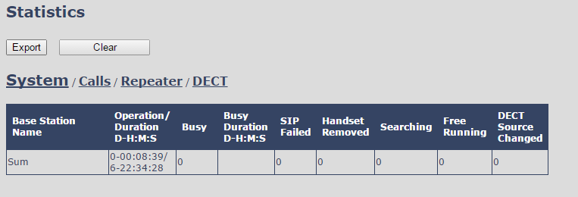

The table is organised with headline row, data pr. base rows and with last row containing the sum of all base parameters.

Parameters | Description
Base Station Name | Base IP address and base station name from management settings
Operation time | Total operation time for the base
Busy Count | Busy Count is the number of times the base has been busy.
Busy Duration | Busy duration is the total time a base has been busy for speech (8 or more calls active).
SIP Failed | Failed SIP registrations count the number of times a SIP registration has failed
Handset Removed | Handset removed count is the number of times a handset has been marked as removed
Searching | Base searching is the number of times a base has been searching for it’s sync source
Free Running | Base free running is the number of times a base has been free running
DECT Source Changed | Number of time a base has changed sync source

Call data
The call data web is access by http://ip/CallStatistics.html and data are organised in a table as shown in below example.

Screenshot
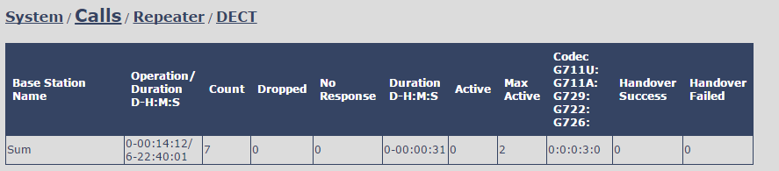

The table is organised with headline row, data pr. base rows and with last row containing the sum of all base parameters.

Parameters | Description
Base Station Name | Base IP address and base station name from management settings
Operation time/Duration | Total operation time for the base since last reboot or reset  Duration is the time from data was cleared or system has been firmware upgraded.
Count | Counts number of calls on a base.
Dropped | Dropped calls are the number of active calls that was dropped.  E.g. if a user has an active call and walks out of range, the calls will be counted as a dropped call. An entry is stored in the syslog when a call is dropped.
No response | No response calls is the number of calls that have no response, e.g. if a external user tries to make a call to a handset that is out of range the call is counted as no response. An entry is stored in the syslog when a call is no response.
Duration | Call duration is total time that calls are active on the base.
Active | Active call shows how many active calls that are active on the base (Not active DECT calls, but active calls). On one base there can be up to 30 active calls.
Max Active | Maximum active calls are the maximum number of calls that has been active at the same time.
Codecs | Logging and count of used codec types on each call.
Handover Success | Counts the number of successful handovers.
Handover Failed | Counts the number of failed handovers.

Repeater data

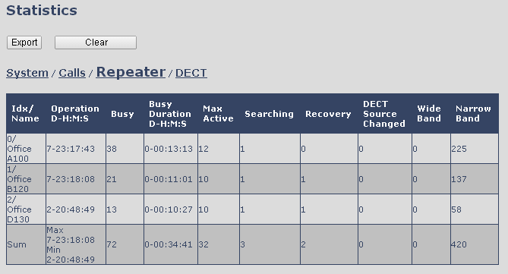

The table is organised with headline row, data pr. base rows and with last row containing the sum of all base parameters.

Parameters | Description
Idx | Base IP address and base station name from management settings
Operation time/Duration | Total operation time for the repeater since last reboot or reset  Duration is the time from data was cleared or system has been firmware upgraded.
Busy | Busy Count is the number of times the repeater has been busy.
Busy Duration | Busy duration is the total time a repeater has been busy for speech (5 or more calls active).
Max Active | Maximum active calls are the maximum number of calls that has been active at the same time.
Searching | Repeater searching is the number of times a repeater has been searching for it’s sync source
Recovery | In case the sync source is not present anymore the repeater will go into lock on another base or repeater and show recovery mode
DECT Source Changed | Number of time a repeater has changed sync source
Wide Band | Number of wideband calls on repeaters
Narrow Band | Number of narrow band calls on repeaters

DECT data
The DECT data web is access by http://ip/DectStatistics.html and data is organised in a table as shown in below example.

Screenshot
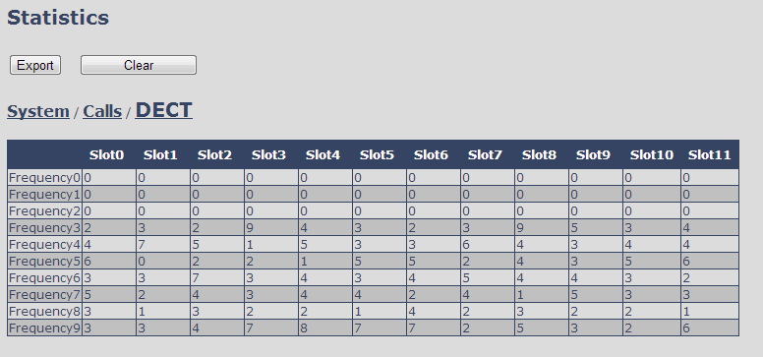
Please note 3 frequencies are manually removed in the example system.

Settings – Configuration File Setup

This page provides non editable information showing the native format of entire VoIP Configuration parameter settings. The settings format is exactly what is used in the configuration file. The configuration file is found in the TFTP server.
The filename for the configuration server is <MAC_Address>.cfg. The configuration file is saved in the folder /Config in the TFTP sever.

There are three ways to edit the configuration file or make changes to the settings page:
- Using the VoIP Configuration interface to make changes. Each page of the HTTP web interface is a template for which the user can customise settings in the configuration file.
- Retrieving the relevant configuration file from the TFTP and modify and enter new changes. This should be done with an expert network administrator.
- Navigate to the settings page of the VoIP Configuration interface > copy the contents of settings > save them to any standard text editor e.g. notepad > modify the relevant contents, make sure you keep the formatting intact > Save the file as <Enter_MAC_Address_of_RFP>.cfg > upload it into the relevant TFTP server.

For details refer to [3].

An example of contents of settings is as follows:

~RELEASE=UMBER_FP_V0054
%GMT_TIME_ZONE%:16
%COUNTRY_VARIANT_ID%:18
%FWU_POLLING_ENABLE%:0
%FWU_POLLING_MODE%:0
%FWU_POLLING_PERIOD%:86400
%FWU_POLLING_TIME_HH%:3
%FWU_POLLING_TIME_MM%:0
%DST_ENABLE%:2
%DST_FIXED_DAY_ENABLE%:0
%DST_START_MONTH%:3
%DST_START_DATE%:1
....
....

Sys log
This page shows live feed of system level messages of the current base station. The messages the administrator see here depends on what is configured at the Management settings. The Debug logs can show only Boot Log or Everything that is all system logs including boot logs.
The Debug log is saved in the file format <Time_Stamp>b.log in a relevant location in the TFTP server as specified in the upload script.
A sample of debug logs is as follows:

0101000013 [N](01):DHCP Enabled
0101000013 [N](01):IP Address: 192.168.10.101
0101000013 [N](01):Gateway Address: 192.168.10.254
0101000013 [N](01):Subnet Mask: 255.255.255.0
0101000013 [N](01):TFTP boot server not set by DHCP. Using Static.
0101000013 [N](01):DHCP Discover completed
0101000013 [N](01):Time Server: 192.168.10.11
0101000013 [N](01):Boot server: 10.10.104.63 path: Config/ Type: TFTP
0101000013 [N](01):RemCfg: Download request of Config/00087b077cd9.cfg from 10.10.104.63 using TFTP
0101000014 [N](01):accept called from task 7
0101000014 [N](01):TrelAccept success [4]. Listening on port 10010
0101000019 [N](01):RemCfg: Download request of Config/00087b077cd9.cfg from 10.10.104.63 using TFTP
0101000019 [W](01):Load of Config/00087b077cd9.cfg from 10.10.104.63 failed

To dump the log simply copy and page the full contents.

SIP Logs

This page shows SIP server related messages that are logged during the operation of the system. The full native format of SIP logs is saved in the TFTP server as <MAC_Address><Time_Stamp>SIP.log
These logs are saved in 2 blocks of 17Kbytes. When a specific SIP log is fully dumped to one block, the next SIP logs are dumped to the other blocks. An example of SIP logs is shown below:

.....
Sent to udp:192.168.10.10:5080 at 12/11/2010 11:56:42 (791 bytes)
REGISTER sip:192.168.10.10:5080 SIP/2.0
Via: SIP/2.0/UDP 192.168.10.101:5063;branch=z9hG4bKrlga4nkuhimpnj4.qx
Max-Forwards: 70
From: <sip:Ext003@192.168.10.10:5080>;tag=3o5l314
To: <sip:Ext003@192.168.10.10:5080>
Call-ID: p9st.zzrfff66.ah8
CSeq: 6562 REGISTER
Contact: <sip:Ext003@192.168.10.101:5063>
Allow: INVITE, CANCEL, BYE, ACK, REGISTER, OPTIONS, REFER, SUBSCRIBE, NOTIFY, MESSAGE, INFO, PRACK
Expires: 120
User-Agent: Generic-DPV-001-A-XX(Generic_SIPEXT2MLUA_v1)
Content-Type: application/X-Generic_SIPEXT2MLv1
Content-Length: 251
.....

To dump the log simply copy and page the full contents.

Registration Management - Handset

In this chapter we briefly describe how to register handsets in the VoIP Network. A precondition for handset registration is a proper configured single or multi-base system. For this refer to chapter Error! Reference source not found..

Register handset to base

This section describes how to register the wireless handset to the base station.

NOTE:
Minimum one server must be registered to the base (system), otherwise a handset cannot be registered to the system. Please see chapter Error! Reference source not found..

- Login to a base station.
- Select “Extensions” URL and click “Add extension” link
- Fill out the form and click “Save”. In the example below we add the extension “3020” and this SIP account got the same number as “Authentication User Name” and “Password”. The “Server 1” is selected by default as server for this extension.
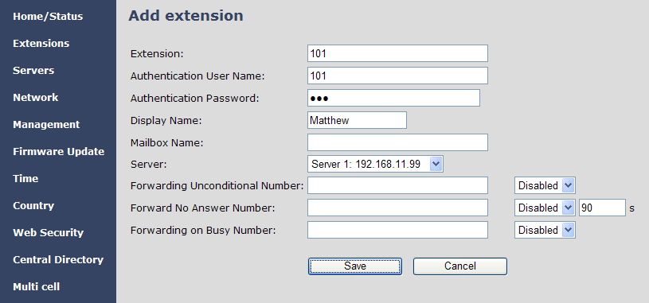

- In the extensions list set a Check mark on the extension which shall be assigned to the handset you want to register and click “Register handset (s)”. The base is now open (ready state) for handset registrations for 5 minutes.

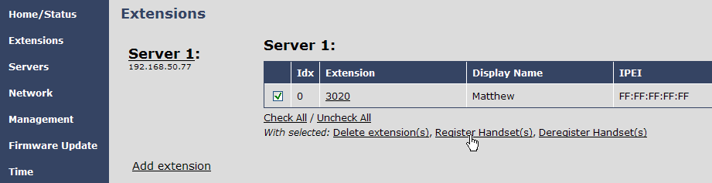

- Start the registration procedure on the handset by following step “a” to “d” below.

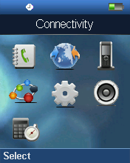
a) Select main menu “Connectivity” b) Select menu ”Register”
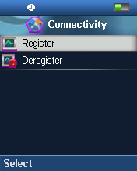

c) Type in the “AC code” and press “OK” to start the registration. The default AC code is “0000”.
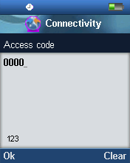

d) After a while the handset is registered, and the idle display is shown.

NOTE:
The unique handset IPEI is displayed on sheet “Extensions” when the handset is successfully registered. The web page must be manually updated by pressing “F5” to see that the handset is registered; otherwise the handset IPEI (International Portable Equipment Identity) isn’t displayed on the web page.

We illustrate how extensions page will be when you register several handsets.
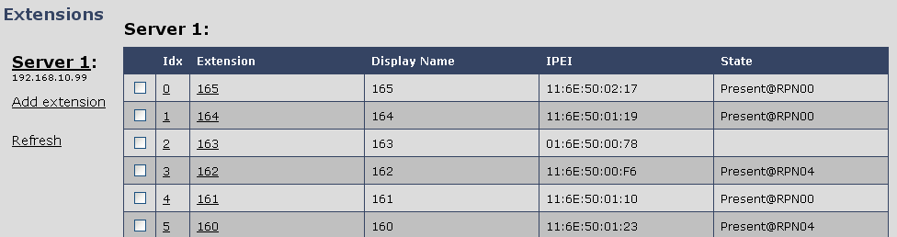

Firmware Upgrade Procedure

This step-by-step chapter describes how to upgrade or downgrade base station(s) and/or handset(s) / repeater (s) to the relevant firmware provided by RTX.

Network Dimensioning

In principle, a number of hardware and software components should be available or be satisfied before base station/handset update can be possible.

The minimum hardware and software components that are required to be able update via TFTP include the following (but not limited to):

- Handsets
- Base stations
- TFTP Server (Several Windows and Linux applications are available)
- DHCP Server (Several Windows and Linux applications are available)
- Workstation (e.g. Normal terminal or PC)
- Any standard browser (e.g. Firefox)
- Public/Private Network

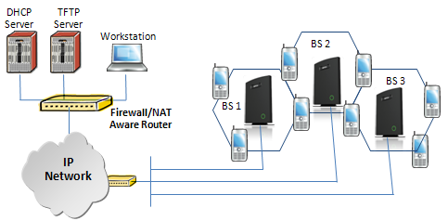

TFTP Configuration
This section illustrate TFTP Server configuration using “SolarWinds” vendor TFTP Server. Create the following relevant folders as shown in the snap shots and choose defaults settings for the remaining options and save.
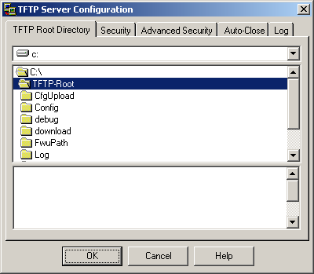
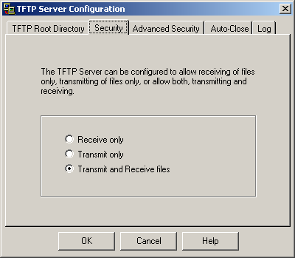

NOTE: If TFTP server timeout settings are too short firmware upgrade might not complete. Recommended time out setting is more than 3 seconds.

Create Firmware Directories

The admin from the service provider’s side must create the relevant firmware directory in the server where both old and new firmware(s) can be placed in it. (See the STEP above)

Base:
On the TFTP server root, create directory “Beatus”.
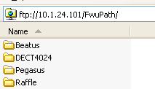

Copy Base station firmware to the named directory.

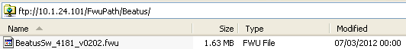

IMPORTANT:
The BeatUs directory name cannot be changed.

Handsets/Repeaters:
On the TFTP server root, create directory “Pegasus” or “Raffle” or “Razor” or “DECT4024” depending on type.

Copy handset/repeater firmware to the named directory.
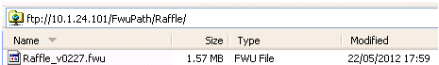

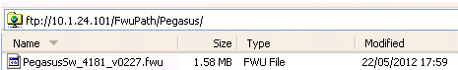

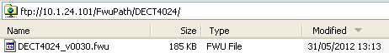

IMPORTANT:
The Raffle, Pegasus, DECT4024 directory names cannot be changed.

Firmware Update Settings

Scroll down and Click on Firmware Update url link in the VoIP Configuration Interface to view the Firmware Update Settings page.

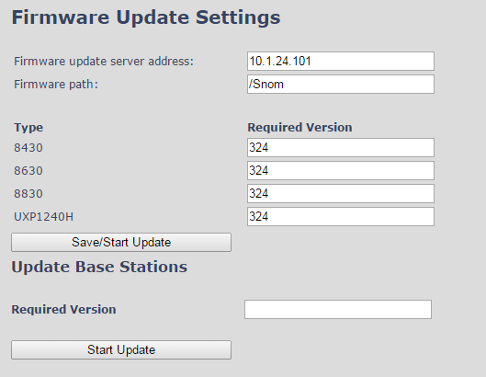

Type IP address and firmware path followed by save.

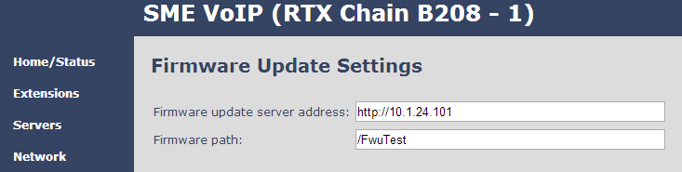
For Http download the firmware update server settings must be entered as follows:

Base Station Firmware Upgrade

On the Firmware Update Settings page > scroll down to the Update Gateways section > Enter the relevant firmware version of the base station to upgrade or to downgrade. Enter 202 for base version V0202.

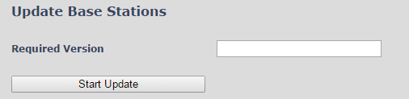

Efter entering required version choose Start update button > select OK button from the dialog window to start the update/downgrade procedure.
The base station will automatically reboot and retrieve the firmware specified from the server and update itself accordingly.

The base firmware update behaviour is: Base will fetch the fwu file for approximately 3 minutes, then reboot and start flashing the LED - indicated by LED fast flashing for approximately 3 minutes and reboots in new version.

Note: All on-going voice calls are dropped from the base station immediately the firmware update procedure starts.

Base firmware confirmation
Base station firmware version status can be seen on the web Welcome page.

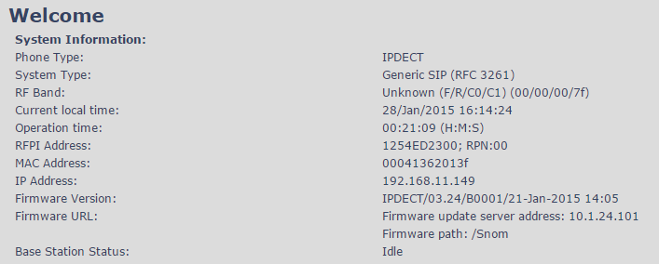

Verification of Firmware Upgrade
Syslog information when Management Syslog level is set to “Debug”

[ FWU Downloading File tftp://10.1.24.101/FwuPath/Beatus/BeatusSw_4181_v0202.fwu]
[ Base FWU started]
[ Base FWU ended with exit code 2101 (NE_FILE_TRANSFER_EOF): End of file]

The log window of the TFTP server:
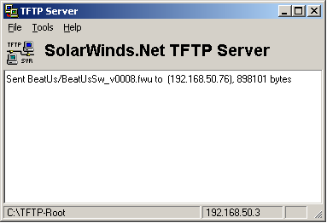

Handset(s) and Repeater Firmware Upgrade

On the Firmware Update Settings page enter the relevant handset/repeater firmware for each type (e.g. 273 for V273) to upgrade or downgrade > press Save button to initialize the process of updating all handsets.

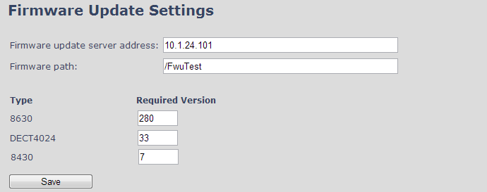

NOTE: To disable handset/repeater firmware process type version 0 in the required version field, followed by the save button. It is recommended to use version 0 after all units are upgraded.
NOTE: For handset TFTP/HTTP download only one handset type can be downloaded at the same time. In case two handset models are defined for fwu at the same time fwu will fail.

Monitor handset firmware upgrade
Handset firmware upgrade status is monitored on the handset extensions page, right column.
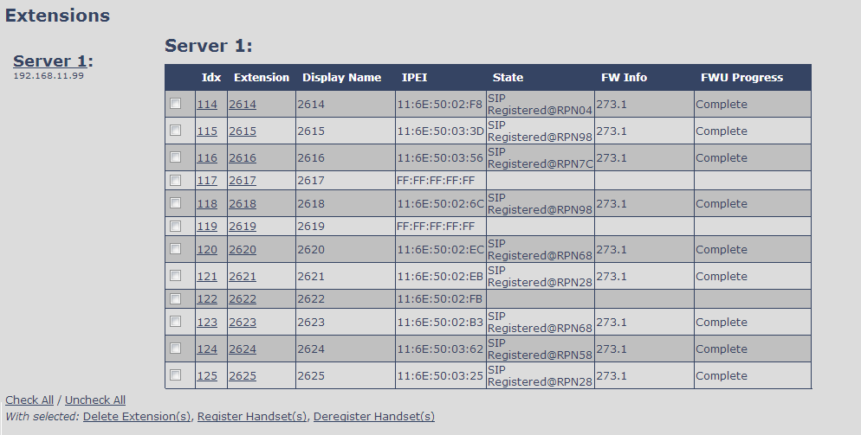

Handset firmware update time from start to complete takes minimum 40 minutes.

Monitor Repeater firmware upgrade
Repeater firmware upgrade status is monitored on the Repeater page, right column.

Repeater firmware upgrade time from start to complete takes minimum 20 minutes.

Verification of Firmware Upgrade
The firmware upgrade is confirmed by the FWU Progress status in the second and first right column on the handset extension list or repeater list. The “FWU info” column contains the software version and the “FWU Progress” column contains the status. In case status is “Complete”, the unit is firmware upgraded.

Alternatively the handset firmware can be verified from the Handset Menu by navigate to Settings > Scroll down to Status this will list information regarding Base station and Handset firmware versions.

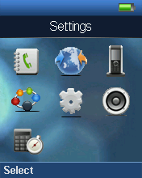 | 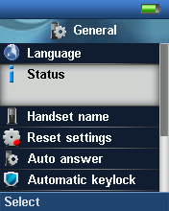 | 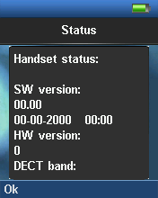

Functionality Overview

So far we have setup our VoIP system. Next, in this chapter we list what features and functionalities are available in the system. The VOIP system supports all traditional and advanced features of most telephony networks. In addition, 3rd party components handle features like voice mail, call forward, conference calls, etc. A brief description of VOIP network functionalities are:

- Outgoing/incoming voice call management: The VOIP system can provide multiple priority user classes. Further, up to 3 repeaters can be linked to a Base-station.
- Internal handover: User locations are reported to SIP Server in order to provide differentiated services and tariff management. Within a DECT traffic area, established calls can seamlessly be handover between Base-station and repeaters using connection handover procedures.

- Security: The RTX VOIP system also supports robust security functionalities for Base-station. Most security functionality is intrinsically woven into the VOIP network structure so that network connections can be encrypted and terminal authentication can be performed.

Base Station Interfaces

Interfaces
Power | Input: 100-240 VAC 50-60Hz (90 – 265 VAC)  Output Nom: 5VDC 1000mA  Type: Switch mode single or multi-plug solution  Plugs: UK, EU, US and AUS
LAN Interface | Standard : 10BASE-T(IEEE 802.3 100Mbps)  Connector: RJ45 8/8
Keys
 | 1: Reset key, Page and Default
LED indicator
 | One Status LED (multicolour, red, green, orange)
RF
Frequency Bands | 1880 – 1900 MHz (EMEA)  1910 – 1930 MHz (Latam)  1920 – 1930 MHz (USA)  Factory setting which can’t be modified after production
Output Power | 250 mW or 140mW depending on country version
Antenna | Two antennas for diversity
Software upgrade
Downloadable | Remote firmware update using HTTP, HTTPS or TFTP
Temperatures
Operation | 0˚C to 40˚C

Software Features

CODEC’s
G.711 PCM A-law & U-law | Yes
G.722 | Yes
G.726 | Yes
G.729 | A/AB (including VAD), max 4 coders  G729 licence not included
SIP
RFC2327 | SDP: Session Description Protocol
RFC2396 | Uniform Resource Identifiers (URI): Generic Syntax
RFC2833 | In-Band DTMF/Out of band DTMF support
RFC2976 | The SIP INFO method
RFC3261 | SIP 2.0
RFC3262 | Reliability of Provisional Responses in the Session Initiation Protocol (PRACK)
RFC3263 | Locating SIP Servers (DNS SRV, redundant server support)
RFC3264 | Offer/Answer Model with SDP
RFC3265 | Specific Event Notification
RFC3326 | The Reason Header Field for the Session Initiation Protocol
RFC3311 | The Session Initiation Protocol UPDATE Method
RFC3325 | P-Asserted Identity
RFC3326 | The Reason Header Field for the Session Initiation Protocol (SIP)
RFC3489 | STUN
RFC3515 | REFER: Call Transfer
RFC3550 | RTP: A Transport Protocol for Real-Time Application
RFC3581 | Rport
RFC3842 | Message Waiting Indication
RFC3891 | Replace header support
RFC3892 | The Session Initiation Protocol (SIP) Referred-By Mechanism
RFC3960 | Early Media and Ringing Tone Generation in the Session Initiation Protocol (SIP)
RFC4475 | Session Initiation Protocol (SIP) Torture Test Messages
SIPS | Secure SIP
In-band DTMF | No
SRTP | Yes, packet authentication will limit the number of calls to 4
SIP registrations | max 20
RTP streams | max 10
SIP transport | UDP, TCP or TLS
Web server
 | Embedded web server, accessed using HTTP
Other features
IP quality | Warning – Network outage, VoIP service outage
Jitter buffer | Yes, adaptive
Automatic DST | Yes
Tone Scheme | Country Depend Tone Scheme
Provisioning | Yes
Re-direct server | Yes
SIP configuration | Yes, from web page or configuration file
Call groups | Yes
IP features
IPv4 | Yes
IPv6 | Hardware ready, software not included
TCP/IP/UDP | Yes
DHCP Support | Yes
DHCP option | 66, 120
Static IP | Yes
DNS srv | Yes
VLAN | Yes, 802.1p/q
Quality of service | Type of Service (ToS) including DiffServ Tagging, and QoS per IEEE 802.1p/q
TLS | Yes, 1.0
Certificates | Yes, X.509 (certificate not included)
TFTP | Yes, for firmware and configuration file download
HTTP server | Yes
HTTP client | Yes, for firmware and configuration file download
HTTPS | Yes, for firmware and configuration file download
SNTP | Yes, For internet clock synchronization
DECT
DECT handover | Yes, inter-cell handover for repeater support
CAT-IQ v1.0 | HD audio or NB audio support
Repeater support | Yes
Intercom | No
DECT encryption | Yes
DECT Authentication | Yes
Group TPUI support | Yes, for call groups
GAP compliant | No
CAT-IQ compliant | No
Handset registrations | 20

Call Features

Call supported | 5 simultaneous call supported
Simultaneous calls/base | 5 Wideband calls (g.722). 5 narrowband calls (PCMA, PCMU, G.726) or 4 when using G729
Simultaneous calls/handset | 2
Call features | Codec Negotiation
 | Codec Switching
 | Missed call notification
 | Voice mssage waiting notification
 | Date and Time synchronization
 | Parallel calls
 | Call Hold
 | Call Retrieve
 | Call transfer unannounced
 | Call transfer announced
 | Conference (3PTY)
 | Conference, Network
 | Call Waiting Indication
 | Calling line identity
 | Outgoing call
 | Call Toggle/Swap
 | Incoming call
 | Line identification
 | Multiple Lines
 | Multiple calls
 | Call identification
 | Calling Name Identification Presentation (CNIP)
 | Calling Line Identification Presentation (CLIP)
 | Call Completed Elsewhere
 | Distinctive Ringing
Central Phone Book:
- LDAP | Yes
- XML | Yes, remote or file load from web interface
- CSV | Yes, file load through web interface
DND: | Yes
Call Forward: | Configurable from base or handset (Not with Call Group active))
- CFU | Yes
- CFNA | Yes
- CFB | Yes
Call groups: | Yes, 1-20 handsets/SIP account

Appendix

Appendix A: Basic Network Server(s) Configuration

In this chapter we describe how to setup the various server elements in the system.

Server setup
In the network, the server environment is installed as a centralized system.
The main server types hosted on the network include SIP, DNS/DHCP and HTTP/TFTP Servers. These servers can be hosted both in one or multiple windows and/or Linux Server environment.
Management servers are normally installed to monitor and manage the network in detail. Each Base-station status can be checked. Each Repeater and each Subscriber Terminal can be monitored over the air from a centralized location.
Further, new software can be uploaded to all system elements from the centralized location (typically a TFTP server) on an individual basis. This includes Subscriber Handsets where the latest software is downloaded over the air.

Requirements

Regardless of whether or not you will be installing a centrally provisioned system, you must perform basic TCP/IP network setup, such as IP address and subnet mask configuration, to get your organization’s phones up and running.

DNS Server Installation/Setup

Name server is a name server service installed in a server for mapping or resolution of humanly memorable domain names and hostnames into the corresponding numeric Internet Protocol (IP) addresses.
The customer should refer to the platform vendor either windows or Linux vendor for detail step-by-step guide on how to install and configure Domain Name System for internet access. In this section, we briefly describe hints on how to setup DNS behind NAT or Firewall.

Hints on how to Configure DNS behind a Firewall/NAT
Proxy and Network Address Translation (NAT) devices can restrict access to ports. Set the DNS to use UDP port 53 and TCP port 53. For windows Servers, set the RCP option on the DNS Service Management console and configure the RCP to use port 135.
These settings should be enough to resolve some of potential issues that may occur when you configure DNS and firewalls/NAT.

DHCP Server Setup
A DHCP Server allows diskless clients to connect to a network and automatically obtain an IP address. This server is capable of supplying each network client with an IP address, subnet mask, default gateway, an IP address for a WINS server, and an IP address for a DNS server. This is very often used in enterprise networks to reduce configuration efforts. All IP addresses of all computers/routers/bases are stored in a database that resides on a server machine.
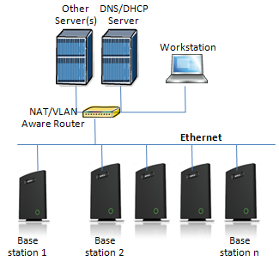

The network administrator should contact the relevant vendors for detail information or step-by-step procedure on how to install and setup DHCP process or service on windows/Linux servers. In this section, we will provide some hints of how to resolve potential problems to be encountered you setup DHCP Servers.

Hint: Getting DHCP Server to Work
Windows Server:
- Clients are unable to obtain an IP address
If a DHCP client does not have a configured IP address; it generally means that the client has not been able to contact a DHCP server. This is either because of a network problem or because the DHCP server is unavailable. If the DHCP server has started and other clients have been able to obtain a valid address, verify that the client has a valid network connection and that all related client hardware devices (including cables and network adapters) are working properly.
- The DHCP server is unavailable
When a DHCP server does not provide leased addresses to clients, it is often because the DHCP service has failed to start. If this is the case, the server may not have been authorized to operate on the network. If you were previously able to start the DHCP service, but it has since stopped, use Event Viewer to check the system log for any entries that may explain the cause.
Next, restart the DHCP service, click Start, click Run, type cmd, and then press ENTER. Type
net start dhcpserver, and then press ENTER.

Linux Platform:
Troubleshooting DHCP, check the following:
- Incorrect settings in the /etc/dhcpd.conf file such as not defining the networks for which the DHCP server is responsible;
- NAT/Firewall rules that block the DHCP bootp protocol on UDP ports 67 and 68;
- Routers failing to forward the bootp packets to the DHCP server when the clients reside on a separate network. Always check your /var/logs/messages file for dhcpd errors.
- Finally restart the dhcpd service daemon

TFTP Server Setup
There are several TFTP servers in the market place; in this section we describe how to setup a commonly used TFTP Server.

TFTP Server Settings
The administrator must configure basic parameters of the TFTP application:
- Specify UDP 69 port – for TFTP incoming requests and TCP 12000 – for remote management of the server. For file transmission the server opens UDP ports with random numbers. In case the option Enable NAT or firewall support is activated on the server, the server uses the same port for files transmission and listening to the TFTP incoming requests (UDP 69 port on default).
- Specify the interface bindings, TFTP root directory, port which the TFTP Server will listen, timeout and number of retries, and TFTP options supported by the server.

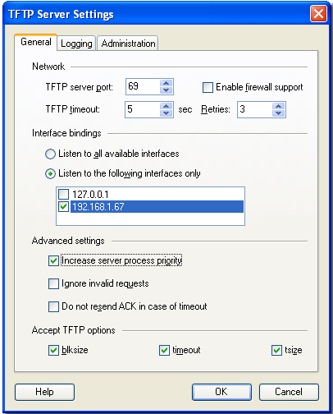

- Configure the relevant TFTP virtual folder in the server. The TFTP virtual folder is the file folder, visible for TFTP clients under a certain name. You can set security settings separately for every virtual TFTP folder. Next, set rights to access TFTP folders according to the relevant clients.
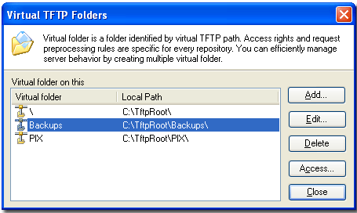

SIP Server Setup
SIP server is one of the main components of a network, dealing with the setup of all SIP calls in the network. A SIP server is also referred to as a SIP Proxy or a Registrar.
Although the SIP server is the most important part of the SIP based phone system, some servers only handles call setup and call tear down. It does not actually transmit or receive any audio. This is done by the media server in RTP.
The RTX family of network phones are fully interoperable with the most of SIP Server applications. There are many off-the-shelf vendor and open source SIP servers. In this section, we will briefly explain settings required to take full advantage of FreePBX SIP Server feature set. The settings are similar for other SIP servers.

FreePBX SIP Server
FreePBX is an easy to use GUI (graphical user interface) that controls and manages Asterisk, which the most popular open source telephony engine software.
The administrator should refer to the relevant detail step-by-step procedure of how to install FreePBX SIP server. This section briefly describes SIP Server setup parameters.
- SIP Server Setup
Settings | Description
NAT | This option determines the settings for users connecting to an asterisk server.  Possible values: Yes, No, Never, Route  NAT=route  Asterisk will send the audio to the port and IP where it’s receiving the audio from. Instead of relying on the addresses in the SIP and SDP messages.  This will only work if the phone behind NAT send and receive audio on the same port and if they send and receive the signalling on the same port. (The signalling port does not have to be the same as the RTP audio port).  NAT=No  Asterisk will add an RPORT to the via header of the SIP messages  NAT=never  This will cause asterisk not to add an RPORT in the VIA line of the sip invite header
Other NAT Settings | Choose the relevant option or enter the settings in IP configuration, External IP, Local Network.
Codecs | Some SIP Servers supports dynamic codec support. Codecs are algorithm used to compress or decompress speech or audio signals. The user should select the relevant Codecs and other speech compression techniques whose traffic will be routed to the network.
Video Codecs | The user should enable this option if network supports video telephony.
Media & RTP Settings | This option should be enabled to provide for deliver media streams (e.g., audio and video) or out-of-band events signalling (DTMF in separate payload type).

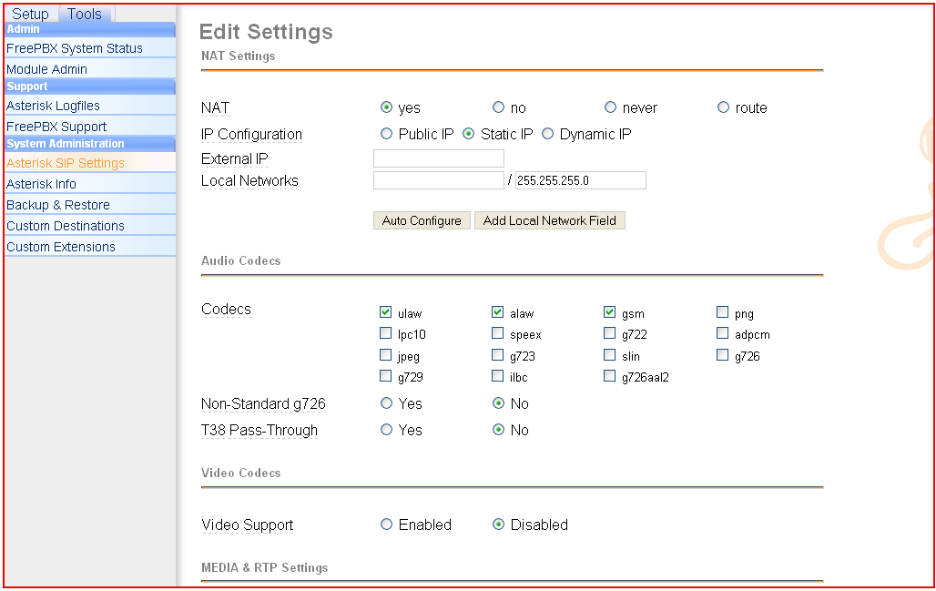
- Extensions
This feature allows administrators create handset profiles in the network. In other words, Extensions describes the Dial plan for the PBX SIP system. Enter the relevant parameters
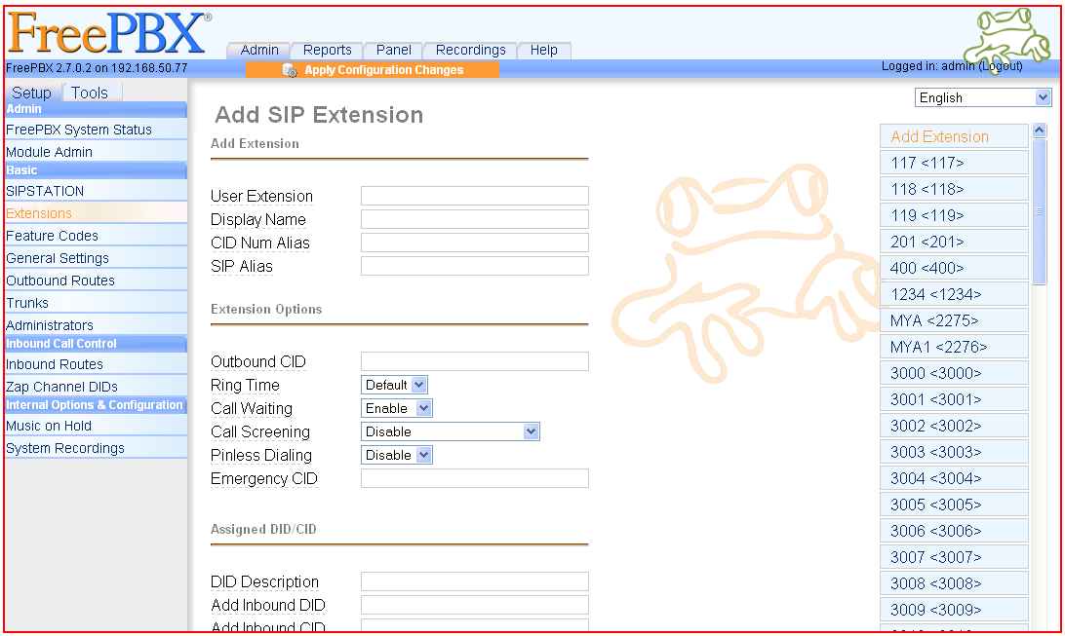

Appendix B: Using Base with VLAN Network
In this chapter we describe how to setup a typical VLAN in the network.

Introduction

In this chapter, we describe how to setup VLAN to typical network. There are three main stages involved in this procedure:

- Configure a VLAN Aware Switch to a specific (un)tagged VLAN ID, so the system can process untagged frames forwarded to it.
- Setup the Time Server (NTP Server) and other relevant network servers.
- Configure the HTTP server in the Base station to access the features in the PBX or system.
VLAN allows administrators to separate logical network connectivity from physical connectivity analogous to traditional LAN which is limited by its physical connectivity. Normally, users in a LAN belong to a single broadcast domain and communicate with each other at the Data Link Layer or “Layer 2”. LANs are segmented into smaller units for each IP subnets and here communication between subnets is possible at the Network Layer or “Layer 3”, using IP routers.
A VLAN can be described as a single physical network that can be logically divided into discrete LANs that can operate independently of each other.
An Illustration of using VLANs to create independent broadcast domains across switches is shown below:
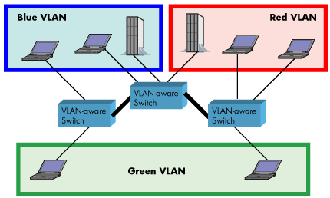
The figure above highlights several key differences between traditional LANs and VLANs.
- All switches are interconnected to each other. However, there are three different VLANs or broadcast domains on the network. Physical isolation is not required to define broadcast domains. If the figure was a traditional LAN without VLAN-aware switches, all stations would belong to one broadcast domain.
- All switch ports can communicate with one another at the Data Link Layer, if they become members of the same VLAN.
- The physical location of an end station does not define its LAN boundary.
  - An end station can be physically moved from one switch port to another without losing its “view of the network”. That is, the set of stations it can communicate with at the Data Link Layer remains the same, provided that its VLAN membership is also migrated from port to port.
  - By reconfiguring the VLAN membership of the switch port an end station is attached to, you can change the network view of the end station easily, without requiring a physical move from port to port.

Backbone/ VLAN Aware Switches

To implement a VLAN in your network, you must use VLAN-aware switches.
Before we continue, let consider two rules to remember regarding the functioning of a regular LAN switch:
- When the switch receives a broadcast or multicast frame from a port, it floods (or broadcasts) the frame to all other ports on the switch.
- When the switch receives a unicast frame, it forwards it only to the port to which it is addressed.
A VLAN-aware switch changes the above two rules as follows:
- When the switch receives a broadcast or multicast frame from a port, it floods the frame to only those ports that belong to the same VLAN as the frame.
- When a switch receives a unicast frame, it forwards it to the port to which it is addressed, only if the port belongs to the same VLAN as the frame.
- A unique number called the VLAN ID identifies each VLAN.

Which VLAN Does a Frame Belong To?
The previous section notes that a frame can belong to a VLAN. The next question is—how is this association made?
- A VLAN-aware switch can make the association based on various attributes of the type of frame, destination of MAC address, IP address, TCP port, Network Layer protocol, and so on.

An illustration of IEEE 802.1Q VLAN tag in Ethernet frame is as follows:
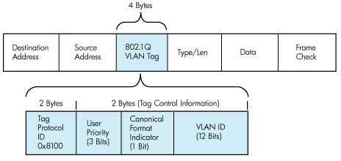

How VLAN Switch Work: VLAN Tagging
VLAN functionality can be implemented via explicit frame tagging by switches and end stations. Network switches and end stations that know about VLANs are said to be VLAN aware. Network switches and end stations that can interpret VLAN tags are said to be VLAN tag aware. VLAN-tag-aware switches and end stations add VLAN tags to standard Ethernet frames–a process called explicit tagging. In explicit tagging, the end station or switch determines the VLAN membership of a frame and inserts a VLAN tag in the frame header (see figure above for VLAN tagging), so that downstream link partners can examine just the tag to determine the VLAN membership.

Implementation Cases
Common types of usage scenarios for VLANs on typical VLAN switches: port-based VLANs, protocol-based VLANs, and IP subnet-based VLANs. Before figuring out which usage scenario suits your needs, you must understand what each type of usage scenario implies.
- Port-based VLAN: All frames transmitted by a NIC are tagged using only one VLAN ID. The NIC does not transmit or receive any untagged frames.
All protocols and applications use this virtual interface’s virtual PPA to transmit data traffic. Therefore all frames transmitted by that NIC port are tagged with the VLAN ID of that Virtual Interface.
- Protocol-based VLAN: The NIC assigns a unique VLAN ID for each Layer 3 protocol (such as IPv4, IPv6, IPX, and so on). Therefore, the VLAN ID of outbound frames is different for each protocol. An inbound frame is dropped if the protocol and VLAN ID do not match.

- IP subnet-based VLAN: The NIC assigns a unique VLAN ID for each IP subnet it belongs to. Therefore, the VLAN ID of outbound frames is different for different destination subnets. An inbound frame is dropped if the IP subnet and VLAN ID do not match.

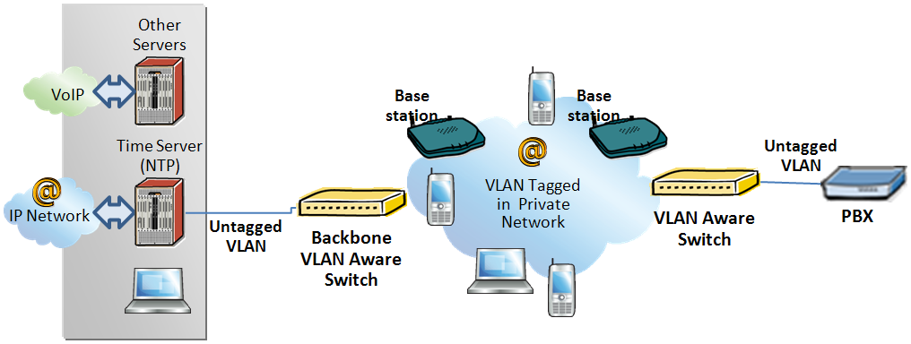

Base station Setup

After the admin have setup the Backbone switch, next is to configure the Base station via HTTP interface.

- Connect the Base station to a private network via standard Ethernet cable (CAT-5).

- Use one of the two methods to find the base IP

- On the Login page, enter your authenticating credentials (the username and password is admin by default unless it is changed). Click OK button.

- Once you have authenticated, the browser will display front end of the Configuration Interface. The front end will show relevant information of the base station.

- Create the relevant SIP server information in the system. Each service provider/customer should refer SIP server vendor on how to setup SIP servers.

Configure Time Server

- Navigate to the Time settings and configure it. Scroll on the left column and click on Time url link to Open the Time Settings Page. Enter the relevant parameters on this page and press the Save button.

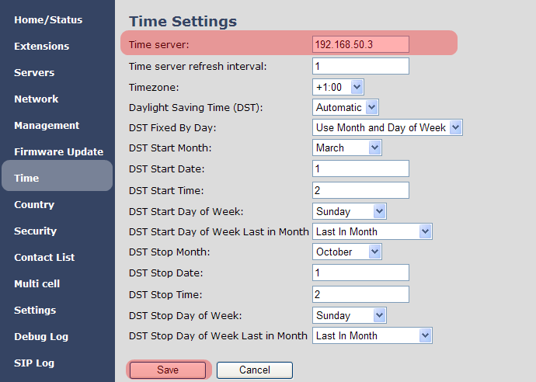

VLAN Setup: Base station

- Navigate to the Network url > On the network page enter the relevant settings in the VLAN section > VLAN Id should be the same as those configured into the backbone.

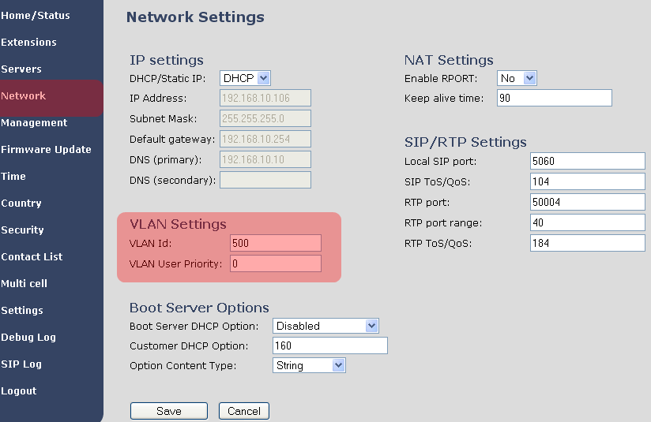

Appendix C: Local Central directory file handling

In this appendix the Local Central Directory file format, import and configuration is described.

Central Directory Contact List Structure

The structure of Contact List is simple. The figure below shows an example of structure of Contact List in Text format and in Xml format. Contact name must not contain more than 23 characters and contact number must not contain more than 21 digits.

.csv or .txt
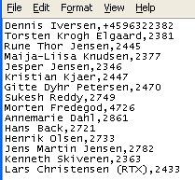

.xml
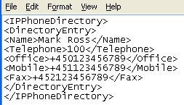

Txt file limitations:
- Contact name must NOT be longer than 23 characters (name will be truncated)
- Contact name must NOT contain “,”
- Contact number must be limited to 21 digits (entry will be discarded, no warning)
- Contact number digits must be: +0123456789
- Contact number does not support SIP-URI
- Spaces between name section “,” and number section is not supported

Central Directory Contact List Filename Format

The Contact list is saved as file format: .txt .csv or .xml

Import Contact List to Central Directory

On the Central Directory page, the admin should click on Browse button and the Choose File to Load dialog window will be shown.

On the Choose File to Upload dialog window, navigate to the directory or folder that contains the right file to be imported to the base station > Click on Open button.

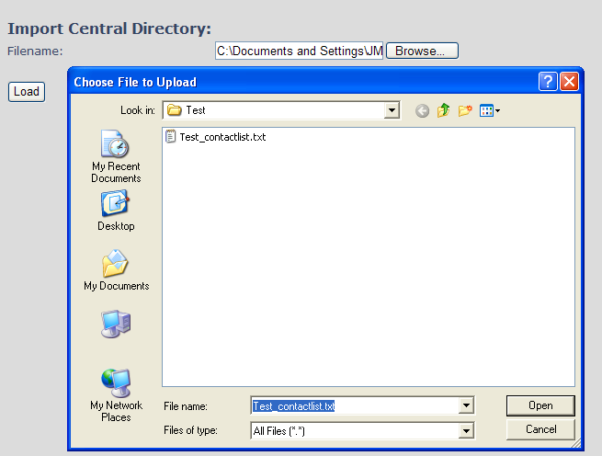
Next, click on the Load button. This will import the contents of contacts in the selected file into the relevant Base station.

The figure below shows the import procedure is in process.

Central directory using server
Alternative way to import a Contact List is to get it from a server. First click on Management url to get Management Settings page, then select the protocol of your server (TFTP/HTTP) in Management Transfer Protocol, then save the setting by clicking Save.
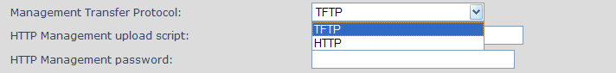
Go back to Central Directory page and enter Server IP address (inclusive the path in the end of the address) and Filename of the contact list, then save the setting by clicking Save. (See example below).
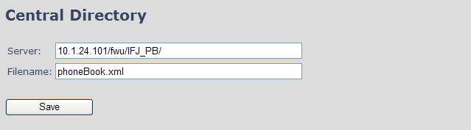

Then reboot the Base station to ensure that the changes take effect.

Verification of Contact List Import to Central Directory
On the Handset, navigate to Central Directory where the correct contact list should populate to the contacts uploaded to the Base station.

With active security 4 channels is supported

